**SUMMER TRAINING (1 Month)**

0

**In**

**ONGC Tripura Power Company Ltd. (OTPC)**

**Combined Cycle Power Plant at Palatana, Tripura**

**in the Department of CONTROL & INSTRUMENTATION(C&I)**



**Title:** Training report on combined cycle power plant, its Control systems and instruments.

**SUBMITTED TO:**

Mr. Mohammad Musa Head of Department (C&I)

OTPC, Palatana.

**SUBMITTED BY:**

*Indrani Chakraborty*

Department Of Electronics and Instrumentation Engineering NATIONAL INSTITUTE OF TECHNOLOGY AGARTALA

**Jirania, Agartala, Tripura-799046**



# Certificate of Originality of Work

**Date:**

This to certify that Miss. Indrani Chakraborty of Electronics and Instrumentation Engineering Department from National Institute Of Technology Agartala, Jirania, West Tripura has successfully completed her training on the topic of "An Introduction to Combined Cycle Power Plant" at ONGC Tripura Power Company Limited, Palatana, Udaipur (Gomati)-799116 from 02-06-2025 to 30-06-2025.

During the period of training at OTPC, Palatana her conduct was found good. She took keen Interest in the training and was found to be most sincere, hardworking and have potential to be a good Executive. The document is a bonafide testimony of the training undergone by her in this course.

We wish every success in her career.

#### Mr. Mohammad Musa

Head-Control and Instrumentation(C&I)

### ACKNOWLEDGEMENT

This Report is based on the Industrial Training which I have undergone in the premises of **ONGC Tripura Power Company Limited (OTPC), 2 X 363.3MW Gas Based Combined Cycle Power Plant, Palatana Power Project, Udaipur, Tripura** from **2nd June 2025 to 30th June 2025.**

I would like to express my sincere gratitude to all those who have contributed to the successful completion of my summer training at ONGC Tripura Power Company Limited (OTPC) ,2×363.3MW, gas based Combined Cycle Power Plant at Palatana, Udaipur, Tripura.

First and foremost, I extend my heartfelt thanks to **HR and Admin Mr. Naren shil** Sir for providing me with the opportunity to undergo this valuable training experience. Your support and encouragement have been instrumental in shaping my learning journey and gaining practical insights into the operations of a combined cycle power plant.

I am immensely grateful to **HOD(C&I) Mr. Mohammad Musa** sir and my mentors and guides **Mr. Manoj Kumar Chauhan** Sir along with **Mr. Siddhartha Kumar Maiti** sir and **Mr. Sandeep Sharma** Sir for their guidance, expertise, and continuous support throughout my training period. Their knowledge, patience, and willingness to share insights have greatly enriched my understanding of the intricate workings of the power plant.

I also extend my appreciation to all the staff and personnel at OTPC Combined Cycle Power Plant for their warm welcome, assistance, and cooperation during my time at the facility. Their professionalism, camaraderie, and willingness to impart knowledge have made my training experience both productive and enjoyable.

I hope that my report will reflect the technical knowledge which I have gained at **ONGC Tripura Power Company Limited (OTPC), 2 X 363.3MW Gas Based Combined Cycle Power Plant, Palatana-799105, Udaipur, Tripura.**

Thank you once again to everyone involved for making my summer training at OTPC a memorable and rewarding experience.

**Trainee ̴ Indrani Chakraborty**

# CONTENTS

|  |  |  |
| --- | --- | --- |
| SL.NO | TOPICS | PAGE NO |
| A | ABSTRACT | 6 |
| 1 | INTRODUCTION | 7-9 |
| 2 | INTRODUCTION TO CCGT | 10 |
| 2.1 | BASIC COMBINED CYCLE | 10-11 |
| 2.2 | STEAM GENERATOR | 11-12 |
| 2.3 | TYPICAL SIZE OF CCGT PLANT | 12 |
| 2.4 | SUPPLEMENTARY FIRING AND BLADE COOLING | 12-13 |
| 2.5 | FUEL FOR COMBINED CYCLE GT | 13 |
| 2.6 | CONFIGURATION OF CCGT PLANTS | 14 |
| 2.7 | OPERATIONAL FLOWCHART | 15 |
| 3 | INTRODUCTION TO GAS TURBINE | 16 |
| 3.1 | AIR SYSTEM | 16 |
| 3.2 | INITIAL GAS CONDITIONING SKID | 16 |
| 3.2.1 | SCRUBBERS | 16-17 |
| 3.2.2 | FILTER SEPARATOR | 17-18 |
| 3.2.3 | CONDENSATE DRAIN TANK | 18 |
| 3.2.4 | FLAME ARRESTOR | 18 |
| 3.2.5 | FLOWDIAGRAM OF ICGS | 19 |
| 3.3 | GAS BOOSTING COMPRESSOR | 20 |
| 3.2.1 | LUBRICATION UNIT | 20 |
| 3.2.2 | GAS BOOSTER COMPRESSOR | 21 |
| 3.2.3 | BY PASS COOLERS | 22 |
| 3.2.4 | ANTI SURGE VALVE | 22 |
| 3.2.5 | COOLING TOWER | 22 |
| 3.2.6 | FLOWCHART OF GBC | 22 |
| 3.4 | FINAL GAS CONDITIONING SKID | 23 |
| 3.4.1 | COALSCENT FILTER | 23 |

# CONTENTS

|  |  |  |
| --- | --- | --- |
| SL. NO | TOPICS | PAGE NO |
| 3.4.2 | PERFORMANCE HEATER | 23 |
| 3.4.3 | SCRUBBERS | 24 |
| 3.4.4 | CONDENSATE DRAIN TANK | 24 |
| 3.4.5 | FLAME ARRESTOR | 24 |
| 3.4.6 | FLOWCHART OF FGCS | 24 |
| 3.5 | GAS TURBINE AND GENERATOR | 25 |
| 3.5.1 | FLOWCHART OF GT | 26 |
| 3.6 | HEAT RECOVERY STEAM GENERATOR (HRSG) | 28 |
| 3.6.1 | HP DRUM AND ECONOMISER | 29 |
| 3.6.2 | IP DRUM AND ECONOMISER | 29 |
| 3.6.3 | LP DRUM AND ECONOMISER | 30 |
| 3.6.4 | EVAPORATORS | 30 |
| 3.6.5 | SUPERHEATERS | 30 |
| 3.6.6 | REHEATERS | 30 |
| 3.6.7 | CYCLIC PROCESS IN HRSG | 30-31 |
| 4 | INTRODUCTION TO ST | 32 |
| 4.1.1 | HIGH PRESSURE SECTION | 32 |
| 4.1.2 | INTERMEDIATE PRESSURE SECTION | 32 |
| 4.1.3 | LOW PRESSURE SECTION | 33 |
| 4.2 | CONDENSATE CYCLE | 34 |
| 4.2.1 | COOLING TOWER | 34-35 |
| 4.3 | DEAERATOR | 35-36 |
| 4.4 | BOILER FEED PUMP | 36-37 |
| 4.5 | PRE TREATMENT PLANT | 37 |
|  | | |

# CONTENTS

|  |  |  |
| --- | --- | --- |
| SL.NO | TOPICS | PAGE NO |
| 4.5.1 | CHLORINE TREATMENT | 37 |
| 4.5.2 | ALUM TREATMENT | 38 |
| 4.5.3 | CAUSTIC SODA TREATMENT | 38 |
| 4.5.4 | INTEGRATED PRE TREATMENT PROCESS | 38-39 |
| 4.5.5 | FLOWCHART OF PT PLANT | 40 |
| 4.6 | DIMINERALISED WATER PLANT | 40 |
| 4.6.1 | ACTIVATED CARBON FILTER | 40 |
| 4.6.2 | DUAL MEDIA FILTER | 41 |
| 4.6.3 | SAC EXCHANGE RESIN | 41 |
| 4.6.4 | SBA EXCHANGE RESIN | 41 |
| 4.6.5 | MIXED BED EXCHANGER | 41 |
| 4.6.6 | pH ADJUSTMENT | 41 |
| 4.6.7 | SILICA REMOVAL | 42 |
| 4.7 | EFFLUENT TREATMENT PLANT | 43 |
| 4.8 | COMPLETE WATER CYCLE | 44 |
| 4.9 | COMPLETE STEAM TURBINE | 45 |
| 5 | NITROGEN PRODUCTION PLANT | 46 |
| 6 | HYDROGEN PRODUCTION PLANT | 46 |
| 7 | SWITCHYARD | 46-47 |
|  | COMPLETE CCGT CYCLE | 48 |
| 8 | CONTROL SYSTEM | 49-52 |
| 9 | FIELD INSTRUMENTS | 53-60 |
| 10 | CALIBRATION INSTRUMENTS | 61 |
| 11 | CONCLUSION | 62 |
| 12 | BIBLIOGRAPHY | 63 |
|  |  |  |

**Abstract**

This training report provides a comprehensive analysis of the gas-based Combined Cycle Power Plant (CCPP) at ONGC Tripura Power Company Ltd. (OTPC), located in Palatana, Tripura. The report is structured to cover all critical aspects of the CCPP, from its technical components and operational procedures to its economic and environmental impacts.

The introduction section offers an overview of the plant's significance in the regional power supply, detailing its capacity and the role of natural gas in its operation. The report then delves into the technical architecture of the plant, explaining the combined cycle process that integrates both gas and steam turbines to enhance efficiency and power output. This section includes detailed descriptions of the key components such as gas turbines, heat recovery steam generators (HRSG), steam turbines, and the control systems along with related instruments that ensure optimal performance. The training emphasized the importance of precise operational parameters and the methodologies to monitor and control various stages of the power generation process.

Additionally, the report covers ancillary systems such as fuel supply mechanisms, cooling water systems and water pre-treatment mechanisms.

Overall, this training report encapsulates a detailed understanding of the gas-based Combined Cycle Power Plant at OTPC, offering valuable insights into its complex operations and significant contributions to the power sector in Tripura.

## 1. INTRODUCTION

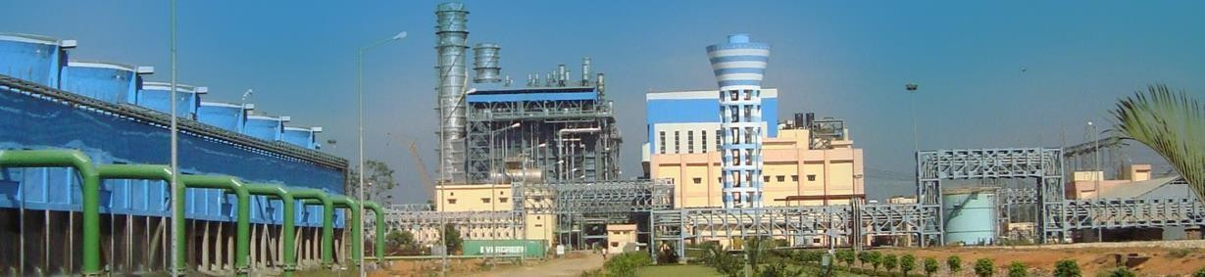

#### ONGC TRIPURA POWER COMAPANY (OTPC)

**ONGC Tripura Power Company** also known as Palatana Power Plant, is a Power Plant Station in Palatana Udaipur in the Gomati district of the Northeastern Indian State of Tripura. It is ONGC’s first Power Plant in India & also the biggest Plant in Northeastern India.

#### CAPACITY

726.6MW Combined Cycle Gas Turbine (CCGT) Power Plant at Palatana, Tripura based on ONGC’s domestic gas supply. The Project is in advanced stage of implementation. EPC contract of Rs 2200 crores has already been awarded to BHEL on August 11,2008. The Generation Project is being domiciled in ONGC Tripura Power Company Ltd, a Special Purpose Vehicle promoted by ONGC, IL&FS Limited and Government of Tripura (GoT).

|  |  |  |  |
| --- | --- | --- | --- |
| Stage | Unit Number | Capacity(MW) | Date of commissioning |
| 1st | 1 | 363.3 | 2013 January |
| 1st | 2 | 363.3 | 2014 November |

#### TRANSMISSION PROJECT

A 400 kV D/C Transmission system connecting Palatana (generation project site) in Tripura to Bongaigaon in Assam over a distance of around 650 km for the evacuation of power from the generation project.

The development and operation of the transmission system would be undertaken by North- East Transmission Company Limited (NETCL) a joint venture of OTPC, Power Grid Corporation of India Ltd (PGCIL) and the North Eastern Region beneficiary states. OTPC has been granted in-principle approval for Mega Power Project (MPP) status by GoI on July 27, 2006 for the Project. The company is applying to MoP, GoI for final approval of MPP status and the same is expected to be obtained shortly. For evacuating Power from the gas based 726.6 MW power Project Generators, a trunk transmission line is being developed by another Special Purpose Vehicle (SPV), jointly promoted by Power Grid Corporation Ltd., OTPC and the North Eastern Region (NER) states. Inter-state and intrastate sub-transmission system and the distribution system within NER states shall be developed by Power Grid Corporation as the Central Transmission Utility (CTU) The Transmission Project was initially envisaged to be domiciled in a separate SPV, North-East Power Transmission Company Limited ("NEPTC") and developed through a BOOT operator.

#### GAS RESERVES

**ONGC**, a Fortune 500 company of the Government of India, owns significant natural gas reserves in the North Eastern state of Tripura. However, these natural gas reserves are yet to be commercially developed due to low industrial demand in the North-Eastern region. The complexities of logistics and attendant costs limit the economic viability of transportation of gas to other parts of the country where gas is in deficit. In order to optimally utilize the gas available in Tripura, ONGC proposes to initially develop a 726.6 MW Combined Cycle Gas Turbine (CCGT) thermal power plant ("the Project") close to its gas fields in the state of Tripura and supply power to the deficit areas of North Eastern States of India.

#### ALLOCATION OF POWER

Allocation of power 660 km long transmission line from the plant to Burnihat in Meghalaya through Silchar in Assam was completed by which power from the first unit could be catered to other states of the north-east. But the work for the 400 kV double circuit high tension line up to Bongaigaon from Burnihat is pending due to forest clearance. The Following are the distribution of electricity to the different Northeastern States of India from the OTPC.

#### 

|  |  |  |
| --- | --- | --- |
| Beneficiary | Power (MW) | |
| Arunachal Pradesh | 22 | |
| Assam | 240 | |
| Manipur | 42 | |
| Meghalaya | 79 | |
| Mizoram | 22 | |
| Nagaland | 27 | |
| Tripura | 196 | |
| Total | 628 |

OTPC will be selling the remaining 98MW electricity.

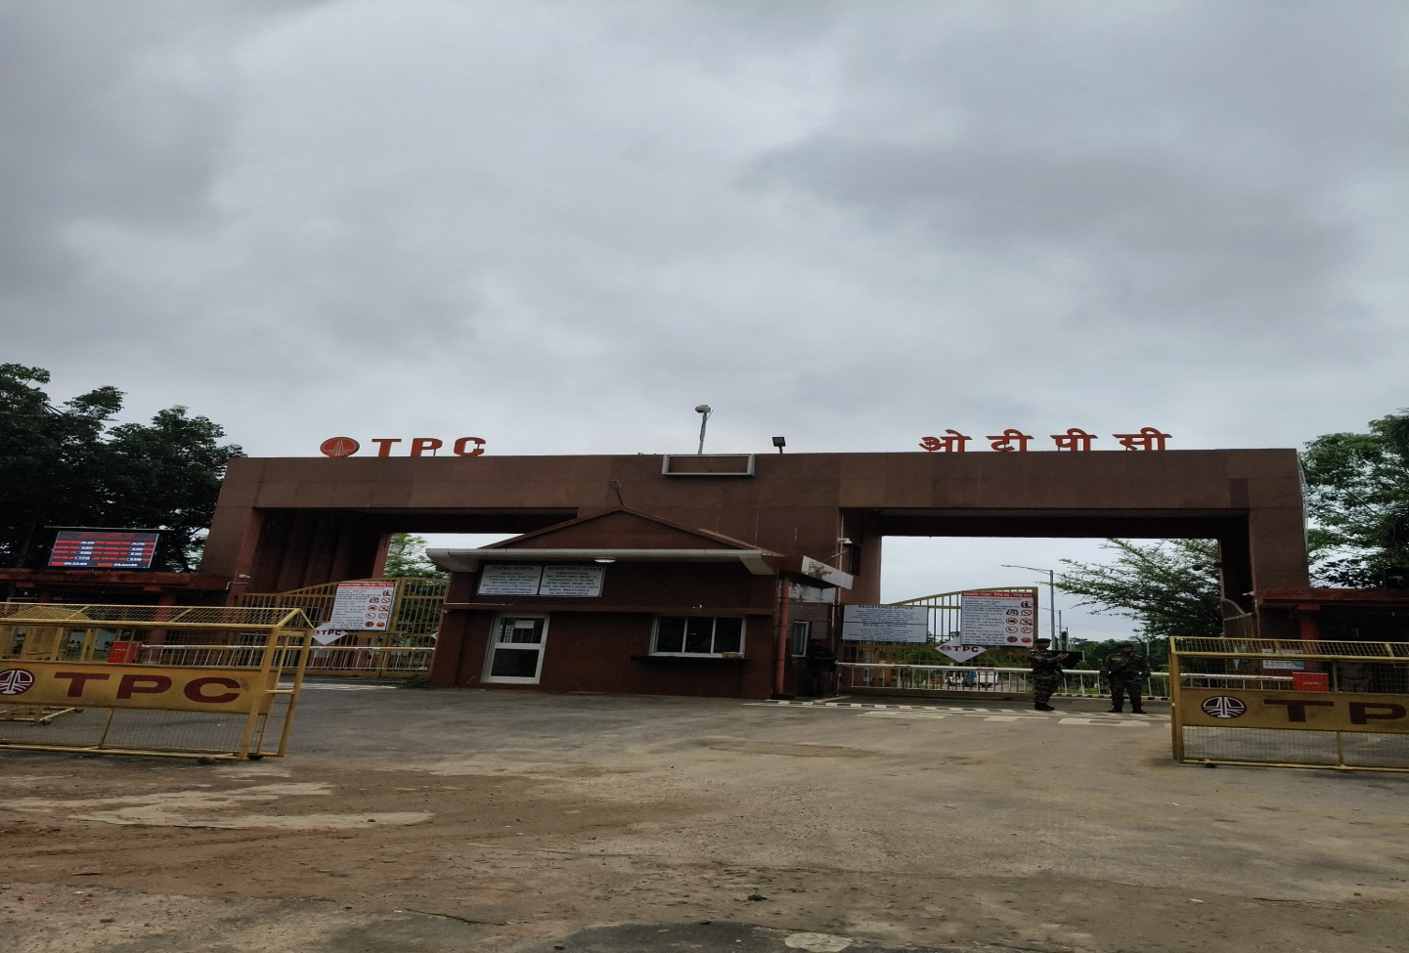

## 2. INTRODUCTION TO COMBINED CYCLE GAS TURBINE

##### COMBINED CYCLE GAS TURBINE

In electric power generation a combined cycle is an assembly of heat engines that work in tandem from the same source of heat, converting it into mechanical energy, which in turn usually drives electrical generators. The principle is that after completing its cycle (in the first engine), the working fluid of the first heat engine is still low enough in its Entropy that a second subsequent heat engine may extract energy from the waste heat (energy) of the working fluid of the first engine. By combining these multiple streams of work, the overall net efficiency of the system may be increased to 50-60 percent. That is, from an overall efficiency of say 34% (in a single cycle) to possibly an overall efficiency of 51% (in a mechanical combination of two (2) cycles) in net Carnot thermodynamic efficiency. This can be done because heat engines are only able to use a portion of the energy their fuel generates (usually less than 50%). In an ordinary (non combined cycle) heat engine the remaining heat (e.g.. hot exhaust fumes) from combustion is generally wasted.

Combining two or more thermodynamic cycles results in improved overall efficiency, reducing fuel costs. In stationary power plants, a widely used combination is a gas turbine (operating on the Brayton cycle) burning natural gas or synthesis gas from coal, whose hot exhaust powers a steam power plant (operating by the Rankine cycle). This is a Combined Cycle Gas Turbine (CCGT) plant, and can achieve a thermal efficiency of around 60%, in contrast to a single cycle steam power plant which is limited to efficiencies of around 35- 42%.

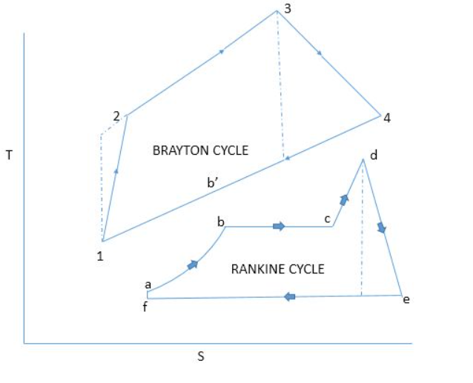

Fig . Topping and Bottoming cycle

##### 2.1 BASIC COMBINED CYCLE

The thermodynamic cycle of the basic combined cycle consists of two power plant cycles. One is the Joule or Brayton cycle which is a gas turbine cycle and the other is Rankine cycle which is a steam turbine cycle. In fig 1, the cycle 1-2-3-4-1 which is the gas turbine power plant cycle is the topping cycle. It depicts the heat and work transfer process taking place in high temperature region. The cycle a-b-c-d-e-f-a which is the Rankine steam cycle takes Page place at a low temperature and is known as the bottoming cycle. Transfer of heat energy from high temperature exhaust gas to water and steam takes place by a waste heat recovery boiler in the bottoming cycle. During the constant pressure process 4-1 the exhaust gases in the gas turbine reject heat. The feed water, wet and super-heated steam absorb some of this heat in the process a-b, b-c and c-d.

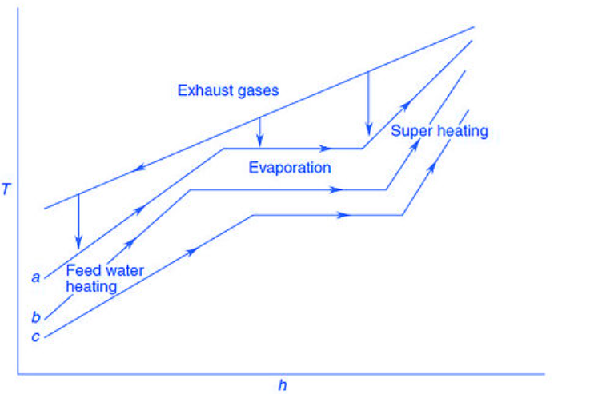

Fig. Heat Transfer from Hot Gases to Water and Steam

##### 2.2 STEAM GENERATORS

The steam power plant gets its input heat from the high temperature exhaust gases from gas turbine power plant. The steam thus generated thus can be used to drive steam turbine. The Waste Heat Recovery Boiler (WHRB) has 3 sections: Economiser, evaporator and superheater.

The efficiency of a heat engine, the fraction of input heat energy that can be converted to useful work, is limited by the temperature difference between the heat entering the engine and the exhaust heat leaving the engine.

In a thermal power station, water is the working medium. High pressure steam requires strong, bulky components. High temperatures require expensive alloys made from nickel or cobalt, rather than inexpensive steel. These alloys limit practical steam temperatures to 655 °C while the lower temperature of a steam plant is fixed by the boiling point of water. With these limits, a steam plant has a fixed upper efficiency of 35 to 42%.

An open circuit gas turbine cycle has a compressor, a combustor and a turbine. For gas turbines the amount of metal that must withstand the high temperatures and pressures is small, and lower quantities of expensive materials can be used. In this type of cycle, the input temperature to the turbine (the firing temperature), is relatively high (900 to 1,400 °C). The output temperature of the flue gas is also high (450 to 650 °C). This is therefore high enough to provide heat for a second cycle which uses steam as the working fluid (a Rankine cycle).

In a combined cycle power plant, the heat of the gas turbine's exhaust is used to generate steam by passing it through a heat recovery steam generator (HRSG) with a live steam temperature between 420 and 580 °C. The condenser of the Rankine cycle is usually cooled by water from a lake, river, sea or cooling towers. This temperature can be as low as 15 °C.

##### 2.3 TYPICAL SIZE OF CCGT PLANT

For large-scale power generation, a typical set would be a 270 MW gas turbine coupled to a 130 MW steam turbine giving 400 MW. A typical power station might consist of between 1 and 6 such sets.

Plant size is important in the cost of the plant. The larger plant sizes benefit from economies of scale (lower initial cost per kilowatt) and improved efficiency. A single shaft combined cycle plant comprises a gas turbine and a steam turbine driving a common generator. In a multi-shaft combined cycle plant, each gas turbine and each steam turbine has its own generator. The single shaft design provides slightly less initial cost and slightly better efficiency than if the gas and steam turbines had their own generators. The multi-shaft design enables two or more gas turbines to operate in conjunction with a single steam turbine, which can be more economical than a number of single shaft units.

The primary disadvantage of single shaft combined cycle power plants is that the number of steam turbines, condensers and condensate systems - and perhaps the number of cooling towers and circulating water systems - increases to match the number of gas turbines. For a multi-shaft combined cycle power plant there is only one steam turbine, condenser and the rest of the heat sink for up to three gas turbines; only their size increases. Having only one large steam turbine and heat sink results in low cost because of economies of scale. A larger steam turbine also allows the use of higher pressures and results in a more efficient steam cycle. Thus the overall plant size and the associated number of gas turbines required have a major impact on whether a single shaft combined cycle power plant or a multiple shaft combined cycle power plant is more economical.

##### 2.4 SUPPLEMENTARY FIRING AND BLADE COOLING

Supplementary firing may be used in combined cycles (in the HRSG) raising exhaust temperatures from 600 °C (GT exhaust) to 800 or even 1000 °C. Using supplemental firing will however not raise the combined cycle efficiency for most combined cycles. For single boilers it may raise the efficiency if fired to 700–750 °C; for multiple boilers however, supplemental firing is often used to improve peak power production of the unit, or to enable higher steam production to compensate for failure of a second unit.

Maximum supplementary firing refers to the maximum fuel that can be fired with the oxygen available in the gas turbine exhaust. The steam cycle is conventional with reheat and regeneration. Hot gas turbine exhaust is used as the combustion air. Regenerative air pre-heater is not required. A fresh air fan which makes it possible to operate the steam plant even when the gas turbine is not in operation, increases the availability of the unit.

The use of large supplementary firing in Combined Cycle Systems with high gas turbine inlet temperatures causes the efficiency to drop. For this reason the Combined Cycle Plants with maximum supplementary firing are only of minimal importance today, in comparison to

simple Combined Cycle installations. However, they have two advantages that is a) coal can be burned in the steam generator as the supplementary fuel, b) has very good part load efficiency.

The HRSG can be designed with supplementary firing of fuel after the gas turbine in order to increase the quantity or temperature of the steam generated. Without supplementary firing, the efficiency of the combined cycle power plant is higher, but supplementary firing lets the plant respond to fluctuations of electrical load. Supplementary burners are also called duct burners.

More fuel is sometimes added to the turbine's exhaust. This is possible because the turbine exhaust gas (flue gas) still contains some oxygen. Temperature limits at the gas turbine inlet force the turbine to use excess air, above the optimal stoichiometric ratio to burn the fuel. Often in gas turbine designs part of the compressed air flow bypasses the burner and is used to cool the turbine blades.

Supplementary firing raises the temperature of the exhaust gas from 800 to 900°C. Relatively high flue gas temperature raises the condition of steam (84 bar, 525°C) thereby improving the efficiency of steam cycle.

##### 2.5 FUEL FOR COMBINED CYCLE GAS TURBINES

The turbines used in Combined Cycle Plants are commonly fueled with natural gas. Global natural gas reserves are expected to be fully consumed by 2070; however the improvement in shale gas extraction through hydraulic fracturing has increased gas supplies and reserves dramatically. Because of this fact, it is becoming the fuel of choice for an increasing amount of private investors and consumers because it is more versatile than coal or oil and can be used in 90% of energy applications.

Where the extension of a gas pipeline is impractical or cannot be economically justified, electricity needs in remote areas can be met with small-scale Combined Cycle Plants, using renewable fuels. Instead of natural gas, Combined Cycle Plants can be filled with biogas derived from agricultural and forestry waste, which is often readily available in rural areas. Combined cycle plants are usually powered by natural gas, although fuel oil, synthesis gas or other fuels can be used. The supplementary fuel may be natural gas, fuel oil, or coal. Biofuels can also be used.

##### 2.6 CONFIGURATION OF CCGT PLANTS

The combined-cycle system includes single-shaft and multi-shaft configurations. The single- shaft system consists of one gas turbine, one steam turbine, one generator and one Heat Recovery Steam Generator (HRSG), with the gas turbine and steam turbine coupled to the single generator in a tandem arrangement on a single shaft. Key advantages of the single- shaft arrangement are operating simplicity, smaller footprint, and lower startup cost. Single- shaft arrangements, however, will tend to have less flexibility and equivalent reliability than multi-shaft blocks. Additional operational flexibility is provided with a steam turbine which can be disconnected, using a synchro-self-shifting (SSS) Clutch, for start up or for simple cycle operation of the gas turbine. Multi-shaft systems have one or more gas turbine- generators and HRSGs that supply steam through a common header to a separate single steam turbine-generator. In terms of overall investment a multi-shaft system is about 5% higher in costs. Single- and multiple-pressure non-reheat steam cycles are applied to combined-cycle systems equipped with gas turbines having rating point exhaust gas temperatures of approximately 540°C or less. Selection of a single- or multiple-pressure steam cycle for a specific application is determined by economic evaluation which considers plant installed cost, fuel cost and quality, plant duty cycle, and operating and maintenance cost.

Multiple-pressure reheat steam cycles are applied to combined-cycle systems with gas turbines having rating point exhaust gas temperatures of approximately 600 °C.

The most efficient power generation cycles are those with unfired HRSGs with modular pre- engineered components. These unfired steam cycles are also the lowest in cost. Supplementary-fired combined-cycle systems are provided for specific application.

The primary regions of interest for cogeneration combined-cycle systems are those with unfired and supplementary fired steam cycles. These systems provide a wide range of thermal energy to electric power ratio and represent the range of thermal energy capability and power generation covered by the product line for thermal energy and power systems.

##### 2.7 OPERATIONAL FLOWCHART

**GENERATOR**



**ELECTRICITY**

**GAS LINE**

**GBC**

**AIR**

**COMBUSTION CHAMBER**

**AIR FILTER**

**EXHAUST GASES**

**GAS TURBINE**

**GENERATOR**

**ELECTRICITY**

**HEAT RECOVERED AT HRSG**

**STEAM TURBINE**

**EXHAUST SMOKE**

**EXHAUST STEAM**

**CONDENSER**



**DE-AERATOR**

**COOLING TOWER**

**BOILER FEED PUMP**

### HEAT OUT

**CT FAN**

**Fig:** Flowchart

##### OTPC CCGT POWER PLANT, PALATANA

The OTPC,CCGT Power Plant is 736.6 MW Power Plant having 2 units. Each units having 1 gas turbine and 1 steam turbine. The rating of the Gas turbine and Steam turbine are 232.39 MW and 130.91 MW respectively in each unit.

The process of CCGT Power Plant can be divided into two major types

1. Gas Turbine

2. Steam Turbine

## 3. INTRODUCTION TO GAS TURBINE

##### 3.1 AIR SYSTEM

For the combustion of fuel inside the gas turbine, air is required. It is supplied by the air system. It mainly consists of the inlet air filter. The filter house consists of 784 sets of filters each set containing one cylindrical and one conical element, which cleans the air for combustion.

##### 3.2 INITIAL GAS CONDITIONING SKID

Gas is obtained from the ONGC supply point through a 20 inch supply pipeline and a 16 inch pipeline and this is led to the initial gas conditioning skid by means of pipelines. A bypass is also provided to the main line containing the flow meter which may be used in case there is a problem in the flow meter. Further two ESDs lead the gas to the conditioning skid.

The main function of the initial gas conditioning skid is to condition the gas and the remove the unnecessary foreign particles and impurities before it is sent to the Gas boosting chambers for compression.

The main components of initial gas conditioning skid are as follows:

• Scrubber

• Filter-Separator

• Condensate Drain Tanks

• Flame arrester

##### 3.2.1 SCRUBBERS

Gas Scrubbers are compactly made mechanical device having a high degree of accuracy. Fuel gas enters into gas scrubbers through 10 inch header where major dust/dirt i.e. solid particles along with liquid get separated out in cyclone tubes. Entered gas contains dust as well as liquid particles takes cyclone path due to construction of tube and then comes out from top of tube. Dust/liquid particles attached on inside surface of tube and fall down by its gravity into bottom portion of vessel from where these can drain out. Before the gas is let into the scrubber it is passed through a Y-strainer to get rid of larger particulate impurities present in the gas. Total number of scrubbers are 4 i.e. 2 scrubbers for each unit.

##### Screenshot 2025-06-26 000432.png

Fig: Scrubber

##### 3.2.2 FILTER SEPARATORS

Filter Separator can play a vital role in helping keep contaminants from damaging the valuable natural gas compressors and turbine in the gas downstream. It removes small solids such as dust and rust as well as lube oil and glycol, thus allowing to produce cleaner natural gas outputs to be sent to the gas compressors.

The natural gas stream first passes through filter tubes and elements that capture solid particles and cause liquids to coalesce into larger droplets, which are then captured by the Wire mesh or vane mist extractor. The resulting stream is typically free of solid particles. Captured dust particles are eventually discharged to drain condensate tank by an automatic control valve. A differential pressure transmitter and indicator which measure the difference between high pressure and low-pressure side of the filter, is used to detect the health of the filter. This is because precipitate collected creates Obstruction in the flow of gases in the filter Which reduces the pressure of outgoing gases as compared to the incoming gases. Hence, DP measures this difference and gives indication of filter's health.

## 

Fig: Filter separator

##### 3.2.3 CONDENSATE DRAIN TANK

All liquid and heavy impurities and foreign particles separated from the gas at the scrubbers and filter separators are collected in the condensate drain tanks.

There are 2 condensate drain tanks in total i.e. 1 for each unit. Each condensate drain tanks is of 2 m³ size. Pumps are provided in the condensate drain tanks in order to empty them when required.

##### 3.2.4 FLAME ARRESTOR

Vents are present at all stages of the gas conditioning and these are connected through a common header to the flame arrester.

The main purpose of the flame arrester is to avoid any kind of accidental fire and any other environmental hazard caused due to the gas.

Scrubber

Main Line

OTPC

Receiving

point

ONGC gas

Supply

Flowmeter

Bypass line

Condensate

Drain tank

Filter

Flame

Arrestor

GBC

**3.2.5 Fig** .Flow diagram of initial gas conditioning skid for a single Unit

#### 3.3 GAS BOOSTING COMPRESSOR

Gas transmission through pipelines may result in pressure drop because of friction losses. Booster compressors are used to restore the pressure drop from these losses as well as raise the pressure of gases to an adequate level. The main components of GBC are:

• Lubrication Unit

• Gas boosters

• Bypass coolers

• Anti-surge Valve

• Water Cooling System

##### 3.3.1 LUBRICATION UNIT

The lubrication unit is used to lubricate the journal and thrust bearings in the gas boosters. The main parts which are lubricated are:

• Two journal bearings of the motor

• Two journal bearings of the compressor along with thrust bearings

• Gear Box

The system consists of two lube oil pumps which pumps the oil to the bearings through cooler, filter etc. There Two lube oil coolers are installed in each of the lubrication unit to cool the lube oil before sending it back to the bearings. A temperature control valve is installed which controls the lube oil temperature as per requirement. The bearings are fed with oil from a 2000 litre overhead tank in case of failure of lube oil pumps. Two nos. of accumulators per lubrication skid is installed to prevent pressure surge while oil comes down from the O/H tank. A centrifuge is also installed with the lubrication unit which is used for cleaning of the lube oil.

##### 3.3.2 GAS BOOSTER COMPRESSOR

The plant has 3 GBC (2 working and I standby). A lot of redundancy can be seen in the power plant to ensure that generation of power never stops. The Gas booster compressors are variable speed motor driven having an energy requirement of 4MW each. Thus, GBCs increase the pressure on the gas and transport it to the gas turbine. The incoming gas at 25 degrees centigrade and 12 kg sq. cm pressure is expelled on the GBC. There is a thrust bearing arrangement to keep the GBC arrangement fixed. The gas is not directly expelled onto the GBC because direct Starting may Cause surging or Stalling. Hence, the gas is passed through the suction valve to GBC and circulated through anti surge valve and back to GBC. Also to maintain the temperature of the inlet gas it is passed through the bypass cooler.

GBC arrangement has an associated gear box and motor chamber with it. The motor rotates it to compress it to an output temperature of 120 deg centigrade and pressure of 32 kg/ sq. cm.

The GBC output is then sent to absolute filter section.

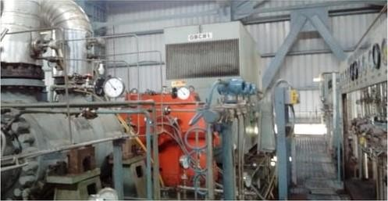

Fig: Gas Booster Compressor

##### 3.3.3 BY-PASS COOLERS

When gas requirement is less, then to resist the flow of access gas, a bypass mechanism with a by-pass cooler is present. Extra gas from the compressor discharge is recirculated back to the suction. The bypass cooler reduces the temperature of the by-passed gas so as to make it at par with the suction conditions and sends it back to the compressor through an anti-surge valve.

##### 3.3.4 ANTI-SURGE VALVE

The compressor is provided with Anti Surge Valve with a Controller to protect the Compressor from surge. The Antisurge controller controls the position of the Antisurge valve that is located in the discharge line, so as to keep the compressor out of surge. It ensures that the duty point does not move to the left of the surge limit even at lower loads. The Antisurge controller acts in response to parameters received from suction flow & discharge pressure.

##### 3.3.5 COOLING TOWER

Water is used as a cooling medium at various stages in the gas boosting chamber such as at lubrication unit and bypass cooler. So a system for cooling d down the used water is required. So there are 3 cooling towers for the purpose each fitted with 4 fans. The water is passed through tubes and the fans cool down the used water. The process is called "Forced Draft Cooling".

Inlet from gas conditioning skid

COMPRESSOR

GEAR BOX

MOTOR

LUBRICATION

SYSTEM

BYPASS

COOLER

Cold water

CENTRIFUGE

hot water

ANTI SURGE VALVE

OIL COOLER

WATER COOLING TOWERS

TOWARDS

GT

**3.3.6 Fig**: Schematic diagram of a single Gas Booster

#### 3.4 FINAL GAS CONDITIONING SKID

The gas from the GBC is led to the Final Gas Conditioning Skid before letting it into the gas turbine through an insulated pipeline to resist the loss in temperature of the gas. The insulator used is glass wool.

The components of final gas conditioning skid are:

• Coalescent Filter

• Performance heater

• Final Scrubber

• Condensate Drain tanks

• Flame arrester

##### 3.4.1 COALSCENT FILTER

The coalescent filters are vertical pressure vessel separated into two stages. For each stage separate liquid/dust holding space is provided. The gas to be filtered enters the vessel in the first stage compartment, wherein the large size solid particles/liquid droplets fall down due to force of gravity and proceed to dust/liquid holding portion at bare bottom of the First Stage Compartment. The selected Coalescer elements are suitable to capture the liquid/solid particles of 0.3 microns and larger which are being trapped in the element media configuration. The liquid droplets do not wet the fibers but remain attached to them as bead of liquid. As more liquid droplets are separated, these droplets agglomerates and coalesces into larger drops due to their surface attraction to one another. When the coalesced liquid drops reach sufficient size, the force of gravity and the frictional drag of the gas cause them to drain out of the element and fall down into the liquid holding portion of the vessel of second stage compartment. There are 4 filters in total, 2 for each unit.

##### 3.4.2 PERFORMANCE HEATER

The gas from the filter enters into the performance heater. The performance heaters are heat exchangers consisting of two interconnected cylinders which heats up the incoming gas from 125°C to 180°C by using the hot water coming from IP feed water system. Gas is required to be heated up to 180°C after 40 MW so as to maintain Wobbe index within proper limits. The gas from performance heater goes to the final Scrubber before going to the turbine. The used water goes to the condenser. There are 2 performance heaters, one for each unit.

##### 3.4.3 SCRUBBER

Final gas scrubber is located at the downstream of performance heater and up stream of gas turbine. Fuel gas enters into final gas scrubbers through 12 inch header where any remaining dust/dirt i.e., solid particles along with liquid get separated out in cyclone tubes. The main purpose of this scrubber is to arrest any carryover of water which may be coming with gas due to leakage in performance heater. Entered gas contains dust as well as liquid particles takes cyclone path due to construction of tube and then comes out from top of the tube. Dust/liquid particles attached on inside surface of tube and fall down by its gravity into bottom portion of vessel from where these can drain out. There are two scrubbers in the final gas conditioning skid, one for each unit.

##### 3.4.4 CONDENSATE DRAIN TANK

All the impurities and foreign particles separated from the gas at the scrubbers and filter separators are collected in the condensate drain tanks.

There are 2 condensate drain tanks in total i.e. 1 for each unit. Each condensate drain tanks is of 30 m³ size. Pumps are provided in the condensate drain tanks in order to empty them when required.

##### 3.4.5 FLAME ARRESTORS

Vents are present at all stages of the final gas conditioning and these are connected through a common header to the flame arrester. The main purpose of the flame arrester is to avoid any kind of accidental fire and any other environmental hazard caused due to the gas.

HW CW

FILTER

AT 125C/33Kgc At 180C/33Kgc

GBC

PERFORMANCE

HEATER

BYPASS

(WHEN LOAD IS LESS THAN 40MW)

CONDENSATE

DRAIN TANKS

#### 

SCRUBBER

GT

FLAME

ARRESTOR

**3.4.6 Fig**: Schematic representation of Final gas conditioning skid

#### 3.5 GAS TURBINE AND GENERATOR

The incoming gas from the GBC at 33 kg/sq. cm pressure and 120 degrees centigrade is expelled to the gas turbine. The gas turbine Converts heat energy from the combustion of natural gas to mechanical energy driving the turbine blades. It is based on the principle of Brayton's Cycle where compressed air is mixed with fuel and burned under constant pressure conditions. The resulting hot gases are allowed to expand through a turbine to perform work. In a Gas turbine about two thirds of this work is spent in driving the air compressor, the rest one third is the produced energy.

The gas turbine mainly consists of three main sections: -

* **The Air filter and compressor**-which draws air into the engine, pressurizes it, and feeds it to the combustion chamber at speeds of hundreds of miles per hour.

**The combustion system**-Typically made up of a ring of fuel injectors that inject a steady stream of fuel into combustion chambers where it mixes with the air. The mixture is burned at temperatures of more than 1200 deg centigrade. The combustion produces a high temperature, high pressure gas stream that enters and expands through the turbine section. There are 18 chambers forming the combustion system. Combustion is initiated by means of discharge from two high voltage electrode spark plugs in chamber I and 2. At the time of firing, one or both sparks of these plugs ignite a chamber. The remaining chambers are ignited by crossfire through the tubes that interconnect the reaction zones of the remaining chambers. Four fire scanners are present in chamber 15, 16,17 &18 that detects the presence of flames to be transmitted to the control system.

* **The turbine**: It is an intricate array of alternate stationary and rotating aero foil-section blades. As hot combustion gas expands through the turbine. it spins the rotating blades. The rotating blades perform a dual function: they drive the compressor to draw more pressurized air into the combustion section, and they spin a generator to produce electricity.

#### 3.5.1 FLOWCHART OF GAS TURBINE

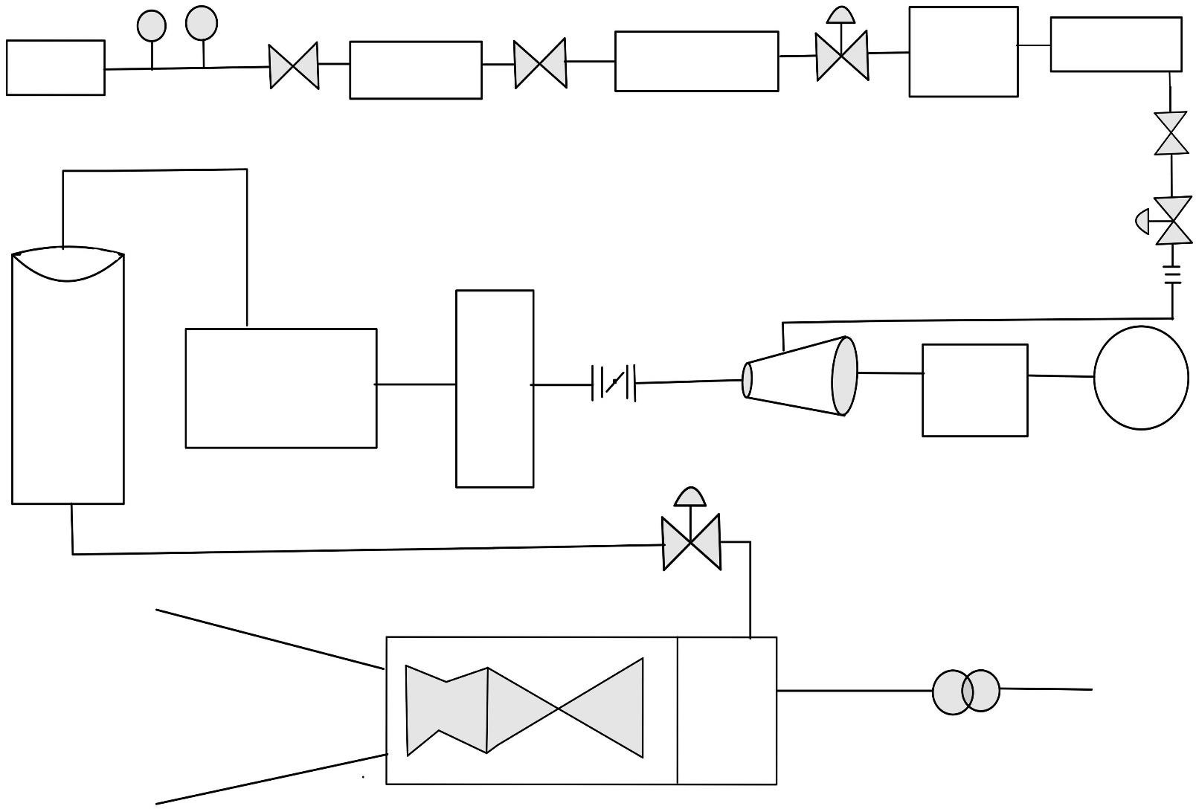

**Ball valve**

**Ball valve**

**Emergency Shutdown valve**

**Ball valve**

**Control valve**

**Scrubber**

**Compressor**

**Emergency Shutdown valve**

**Duct Exhaust**

**Accessory Skid**

**Transformer**

**Gear**

**BOX**

**Induction Motor**

**Performance heater**

**Coalescent Filter**

**Orific plate**

**Ultrasonic flowmeter**

**Natural Gas**

**Chromatography**

**Filter**

**Scrubber**

**Performance**

**Heater**

Gas Turbine



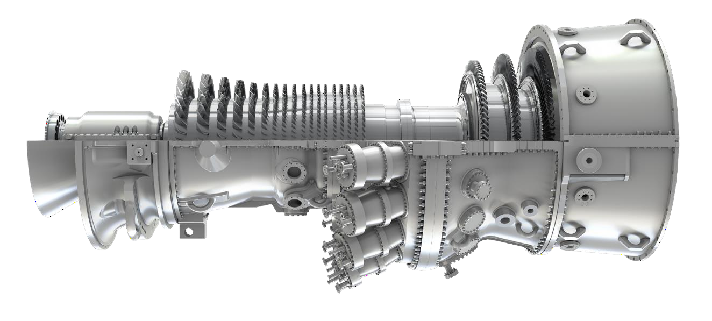

**Fig:** 9 FA Gas turbine

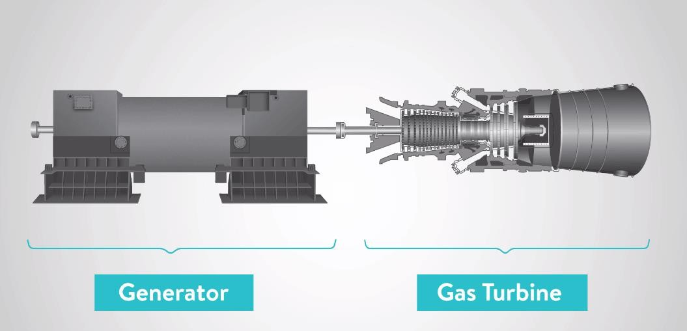

**Fig:** GT and Generator coupling

#### 3.6 HEAT RECOVERY STEAM GENERATOR (HRSG)

The heat is recovered from exhaust gas of gas turbine by HRSG and then this heat is used to make steam of water in a boiler. This steam is used to turn the steam turbine which also drives another generator. The exhaust smoke is coming outside through chimney. The steam is condensed in the condenser and recycled to where it was heated; this is known as Rankine Cycle.

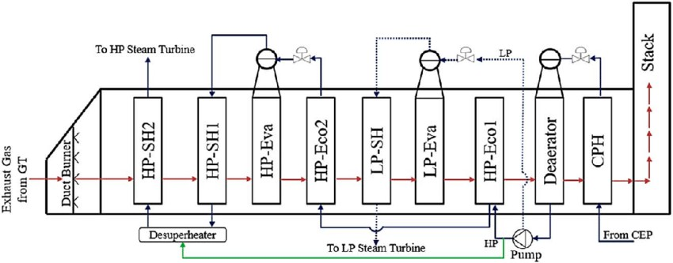

**Fig:** HRSG cyclic representation

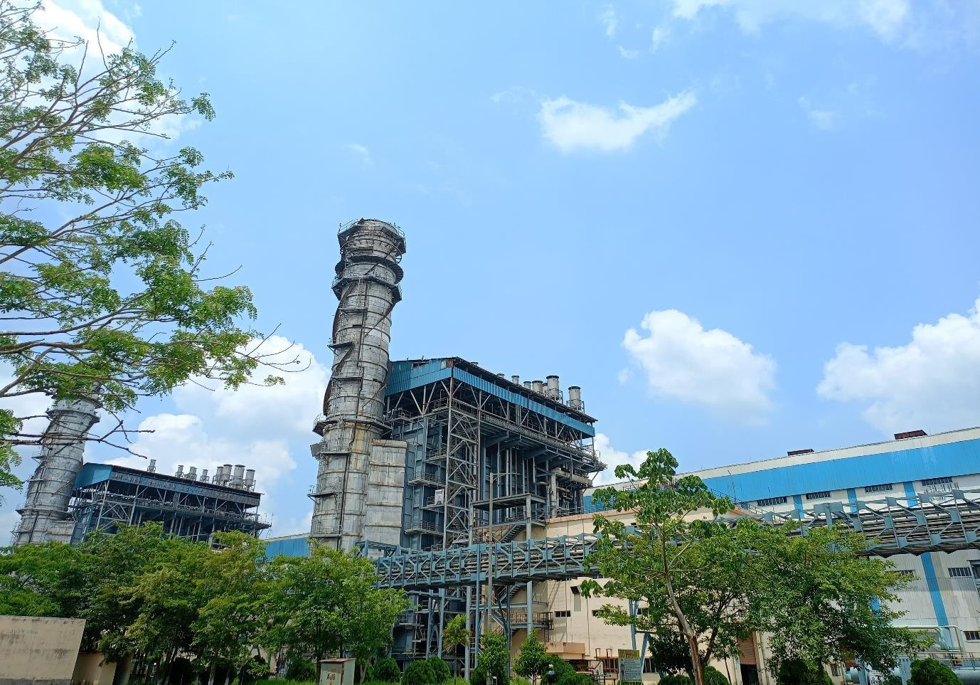

**Fig:** HRSG at OTPC

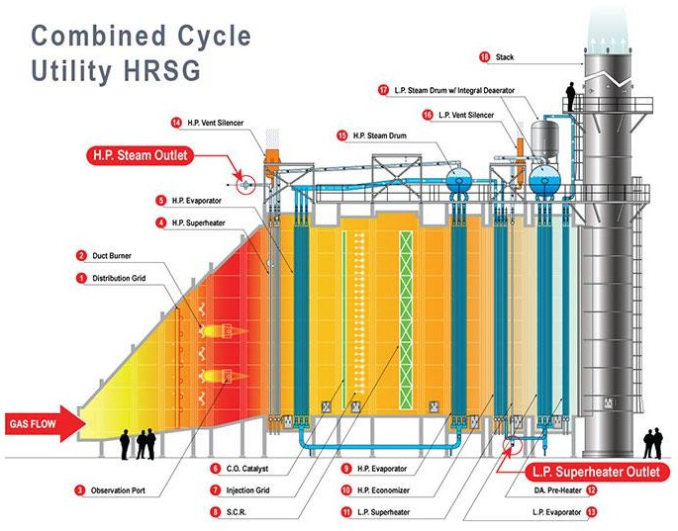

### COMPONENTS OF HRSG:

###### 3.6.1 High-Pressure (HP) Drum and Economizer

The high-pressure drum is a key component in the HRSG, serving as the separator of steam and water in the evaporator section. It collects saturated steam generated in the high-pressure evaporator and delivers it to the superheater. The high-pressure economizer, located before the high-pressure evaporator in the gas flow path, preheats the feedwater using residual heat from the exhaust gases. This preheating is essential as it increases the efficiency of the evaporation process by reducing the thermal shock to the evaporator tubes and enhancing the overall heat transfer.

###### 3.6.2 Intermediate-Pressure (IP) Drum and Economizer

Similar to the high-pressure drum, the intermediate-pressure drum functions as a separator for the steam and water mixture produced in the intermediate-pressure evaporator. The saturated steam collected here is then superheated in the intermediate- pressure superheater. The intermediate-pressure economizer preheats the feedwater destined for the intermediate-pressure evaporator, utilizing the heat remaining in the exhaust gases after they pass through the high-pressure sections. This staged heating process maximizes the energy extracted from the exhaust gases.

###### 3.6.3 Low-Pressure (LP) Drum and Economizer

The low-pressure drum operates at a lower pressure compared to the high and intermediate-pressure drums, handling the steam-water mixture produced in the low- pressure evaporator. The low-pressure economizer is the final stage of feedwater preheating before the water enters the low-pressure evaporator. By the time the exhaust gases reach this stage, they have significantly cooled down, yet still contain sufficient energy to preheat the feedwater, thus optimizing the overall thermal efficiency of the HRSG.

###### 3.6.4 Evaporators

Evaporators are critical for converting preheated feedwater into steam. They are divided into high-pressure, intermediate-pressure, and low-pressure sections, each associated with its respective drum. The evaporators consist of a network of tubes through which the feedwater circulates and absorbs heat from the exhaust gases. This process of heat absorption causes the water to boil and form a steam-water mixture. The design and configuration of the evaporators are essential for ensuring efficient heat transfer and minimizing pressure drop.

###### 3.6.5 Superheaters

Superheaters play a vital role in increasing the temperature of the saturated steam produced in the evaporators. Located after the evaporators in the gas flow path, superheaters raise the temperature of the steam beyond its saturation point, producing superheated steam. This superheated steam is crucial for improving the efficiency of the steam turbine, as it allows for more energy extraction and reduces the moisture content in the turbine, which can cause damage and reduce efficiency.

###### 3.6.6 Reheaters

Reheaters are used to reheat the steam that has partially expanded in the steam turbine. After the steam has done some work in the high-pressure turbine, it returns to the HRSG and passes through the reheater, where it is heated again before entering the intermediate or low-pressure turbines. This reheating process increases the enthalpy of the steam, which allows for additional energy extraction in the subsequent stages of the turbine, enhancing the overall efficiency of the power cycle.

##### 3.6.7 Cyclic Process in HRSG

The cyclic process within an HRSG in a combined cycle power plant is designed to maximize the recovery and utilization of heat from the gas turbine exhaust. Here is a brief account of the process:

* + - 1. **Gas Turbine Exhaust:** Hot exhaust gases from the gas turbine enter the HRSG, initially encountering the high-pressure economizer.
      2. **High-Pressure Economizer:** The exhaust gases preheat the high-pressure feedwater, which then flows to the high-pressure drum.
      3. **High-Pressure Drum and Evaporator:** The preheated water from the economizer is converted into a steam-water mixture in the high-pressure evaporator. The steam is separated in the high-pressure drum and directed to the high-pressure superheater.
      4. **High-Pressure Superheater:** The saturated steam is superheated, increasing its temperature before it enters the high-pressure steam turbine.
      5. **Intermediate-Pressure and Low-Pressure Stages:** The process is repeated at intermediate and low-pressure levels, with the exhaust gases passing through the respective economizers, evaporators, drums, and superheaters.
      6. **Reheating:** After the high-pressure steam expands in the turbine, it returns to the HRSG for reheating in the reheater section before being used in the intermediate or low-pressure turbines.
      7. **Final Heat Recovery:** The exhaust gases, now significantly cooled, pass through the low-pressure economizer before being released to the atmosphere through the stack.

## 4. INTRODUCTION TO STEAM TURBINE:

In a combined cycle power plant, the steam turbine plays a crucial role in converting thermal energy from steam into mechanical energy, which is then transformed into electrical energy by a generator. The steam turbine typically consists of three main sections: High-Pressure (HP), Intermediate-Pressure (IP), and Low-Pressure (LP) stages, each designed to maximize efficiency by extracting energy from steam at different pressures. Below is a detailed explanation of the steam turbine and its main sections, along with the steam generator.

It is an advanced piece of machinery designed to work in conjunction with a gas turbine to improve overall efficiency. The gas turbine generates power and produces high- temperature exhaust gases. These exhaust gases are then used to produce steam in a Heat Recovery Steam Generator (HRSG), which is directed to the steam turbine. The steam turbine converts the energy from the steam into rotational energy to drive an electrical generator.

###### 4.1.1 High-Pressure (HP) Section

* **Function:** The HP section is the first stage of the steam turbine, where high- pressure, high-temperature steam from the HRSG enters the turbine.
* **Operation:** Steam enters the HP section at high pressure and temperature (typically around 100-140 bar and 500-600°C). It expands through the turbine blades, losing pressure and temperature while transferring energy to the turbine rotor.
* **Design:** The HP turbine is designed to handle the highest pressures and temperatures in the system. It consists of a series of stationary and rotating blades arranged in stages to extract maximum energy from the steam.

###### 4.1.2 Intermediate-Pressure (IP) Section

* **Function:** After passing through the HP section, the partially expanded steam returns to the HRSG for reheating. The reheated steam, at a slightly lower pressure but high temperature, enters the IP section.
* **Operation:** In the IP section, steam is further expanded, reducing its pressure and temperature while transferring more energy to the turbine rotor.
* **Design:** The IP turbine blades and casing are designed to handle intermediate pressure and temperature levels. This section ensures that the steam's thermal energy is efficiently converted into mechanical energy.

###### 4.1.3 Low-Pressure (LP) Section

* **Function:** The LP section is the final stage of the steam turbine, where the steam is at its lowest pressure and temperature.
* **Operation:** Steam enters the LP section after exiting the IP section. Here, it undergoes further expansion, dropping to near atmospheric pressure, and transfers the remaining energy to the turbine rotor.
* **Design:** The LP turbine blades are much larger due to the lower pressure and density of the steam. This section typically includes multiple stages to maximize energy extraction from the low-pressure steam.

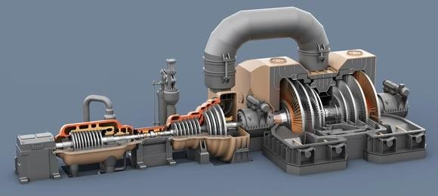

**Fig:** Steam Turbine

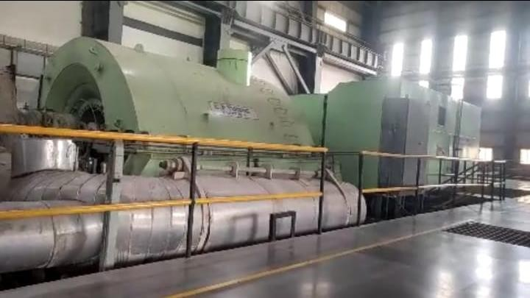

**Fig:** Steam Turbine and Generator

#### 4.2 CONDENSATE CYCLE

Condenser is a device or unit used to condense the exhaust gases from the LP turbine to its liquid State, typically by cooling it.

The exiting steam from the LP steam turbine, now a little above its boiling point, is brought into thermal contact with cold water (pumped in from the cooling tower) in the condenser where it condenses rapidly back into water. In condenser a Vacuum pump is present; it creates a vacuum in the condenser so that the exhaust steam can enter into condenser from steam turbine easily). If vacuum pump is not present then when the steam enters into the condenser that time a back thrust created as a result steam again goes back to the turbine. The condensed steam is stored in condenser also known as Hotwell.

Two Condensate Extraction Pumps (I working and I standby) are used to pump the water from the Hotwell to Deaerator through gland Steam condenser. The pumps are operated When there is a certain amount of water present in the Hotwell. Initially the discharge valve of the pump is closed and minimum recirculation line is kept open to limit the inrush current.

**4.2.1 Cooling Tower**- Cooling towers are heat removal devices used to transfer process waste heat to the atmosphere. Cooling towers constitute of fans rotating at high speed to use the evaporation of water to remove process heat and cool the water coming back from condenser.

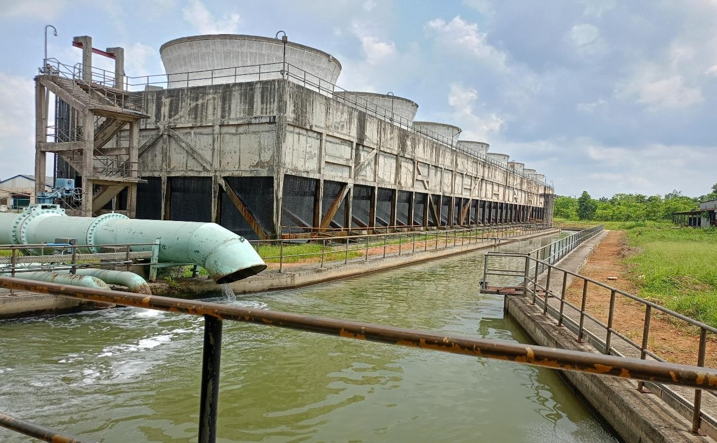

**Fig**: Cooling Tower

**Fig:** Cooling tower flow diagram

#### 4.3 DEAERATOR

A de-aerator is a crucial component in a combined cycle power plant, primarily responsible for removing dissolved gases, such as oxygen and carbon dioxide, from the feedwater. These gases, if not removed, can cause corrosion in the boiler, steam turbine, and other parts of the plant. Here's a detailed look into the role, functioning, and types of de-aerators used in combined cycle power plants.

##### Role of De-aerator in Combined Cycle Power Plant

1. **Corrosion Prevention**: Oxygen and carbon dioxide in the feedwater can cause serious corrosion problems in boilers, steam turbines, and piping systems. Oxygen leads to pitting and general corrosion, while carbon dioxide can form carbonic acid, which further lowers the pH and accelerates corrosion.
2. **Thermal Efficiency**: By preheating the feedwater and removing non-condensable gases, the de-aerator improves the thermal efficiency of the plant. The feedwater entering the boiler is already at a higher temperature, reducing the amount of fuel needed to heat it to the desired level.
3. **Safety and Reliability**: Consistent removal of gases ensures the longevity and safe operation of the plant. It minimizes the risks associated with corrosion-related failures, such as leaks and ruptures, which can lead to unplanned shutdowns and maintenance costs.

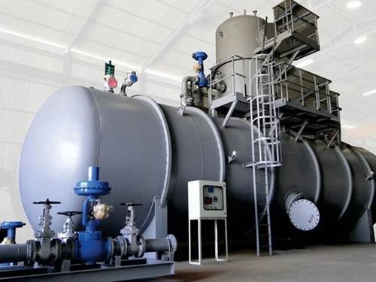

#### Fig: De-aerator

#### 4.4 BOILER FEED PUMP (BFP)

The Boiler Feed Pump (BFP) in a combined cycle power plant's Heat Recovery Steam Generator (HRSG) involves several key processes to ensure efficient and reliable steam generation. The BFP draws feedwater from a condensate tank or a de-aerator, where dissolved gases are removed to prevent corrosion, and then uses a series of impellers in a multi-stage centrifugal pump to progressively increase the water pressure to the levels required by the HRSG. This high-pressure feedwater is then fed into the HRSG, where it absorbs heat from the exhaust gases of the gas turbine, converting it into high-pressure steam. Advanced control systems continuously monitor and adjust the BFP’s operation to maintain optimal pressure and flow rates, accommodating varying load demands. The precise regulation of feedwater temperature and pressure ensures efficient heat exchange and steam production while minimizing thermal stress on the HRSG components. Regular maintenance, including inspections and the use of predictive techniques like vibration analysis, helps identify wear or potential failures, ensuring the BFP operates reliably and efficiently, ultimately supporting the overall performance and efficiency of the combined cycle power plant.

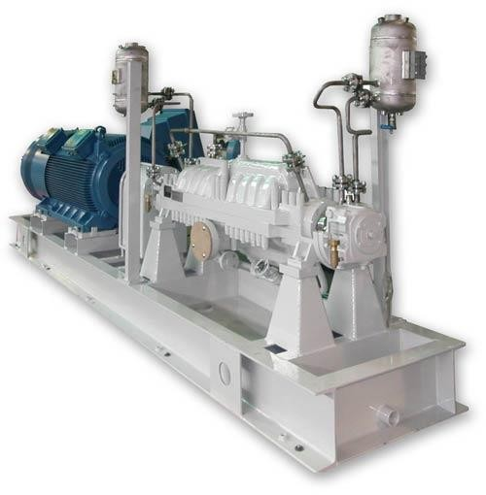

**Fig:** Boiler Feed Pump

#### 

#### 4.5 PRE-TREATMENT PLANT (PT PLANT)

The pre-treatment plant is essential for ensuring that the water used in the process is of the required quality to avoid damage to the equipment and to ensure efficient operation. The pre-treatment plant typically involves several stages of water treatment, including coagulation, flocculation, sedimentation, filtration, and disinfection. Here is a detailed explanation of how chlorine, alum, and caustic soda are used in the pre-treatment process:

##### 4.5.1 Chlorine Treatment

**Purpose**: Disinfection and Oxidation

* + - * **Disinfection**: Chlorine is used to kill or inactivate microorganisms such as bacteria, viruses, and protozoa. This step is crucial to prevent biofouling in the water systems of the power plant.
      * **Oxidation**: Chlorine can also oxidize certain impurities, such as iron and manganese, converting them into forms that can be more easily removed in subsequent treatment stages.

###### Process:

* + - * Chlorine gas or sodium hypochlorite solution is added to the raw water.
      * The chlorine reacts with organic and inorganic materials, leading to the formation of by-products and the elimination of microorganisms.

##### 4.5.2 Alum Treatment

**Purpose**: Coagulation and Flocculation

* + - * **Coagulation**: Alum (aluminium sulphate) is added to the water to destabilize colloidal particles, which are too small to settle or filter out by conventional means.
      * **Flocculation**: Following coagulation, the destabilized particles clump together to form larger particles called flocs, which can then be removed from the water.

###### Process:

* + - * Alum is dosed into the water, where it dissociates to form aluminium ions.
      * These ions neutralize the negative charges on the colloidal particles, allowing them to aggregate into larger flocs.
      * Gentle mixing ensures the flocs grow to a size that can be removed by sedimentation or filtration.

##### 4.5.3 Caustic Soda Treatment

**Purpose**: pH Adjustment

* + - * **pH Adjustment**: Caustic soda (sodium hydroxide) is used to adjust the pH of the water. This step is important because the effectiveness of coagulation and other chemical reactions depends on maintaining the water at an optimal pH level.

###### Process:

* + - * Caustic soda is added to the water to increase the pH.
      * This adjustment helps to optimize the performance of the alum, ensuring effective coagulation.
      * Maintaining an appropriate pH also helps to prevent corrosion and scaling in the downstream equipment and pipelines.

##### 4.5.4 Integrated Pre-Treatment Process

###### Sequential Steps:

1. **Chlorination**: The raw water is first treated with chlorine to disinfect and oxidize contaminants.
2. **Coagulation and Flocculation**: Alum is then added to coagulate and flocculate the particles, forming larger flocs.
3. **pH Adjustment**: Caustic soda is added to adjust the pH to the optimal level for coagulation and to maintain the integrity of the equipment.

###### Subsequent Treatment Steps:

* + **Sedimentation**: The water flows into a sedimentation basin where the heavy flocs settle to the bottom, and the clarified water is collected from the top.
  + **Filtration**: The clarified water is then passed through filters (such as sand or multimedia filters) to remove any remaining suspended particles.
  + **Post-treatment Disinfection**: Additional chlorine or other disinfectants may be added to ensure the water remains free of pathogens as it moves through the plant.

##### Importance in Combined Cycle Power Plants

* + **Preventing Scaling and Fouling**: Proper pre-treatment prevents scaling and fouling in boilers and heat exchangers, which can reduce efficiency and lead to equipment damage.
  + **Protecting Equipment**: By removing harmful contaminants and adjusting pH, the pre-treatment process helps to protect turbines, condensers, and other critical equipment from corrosion and erosion.
  + 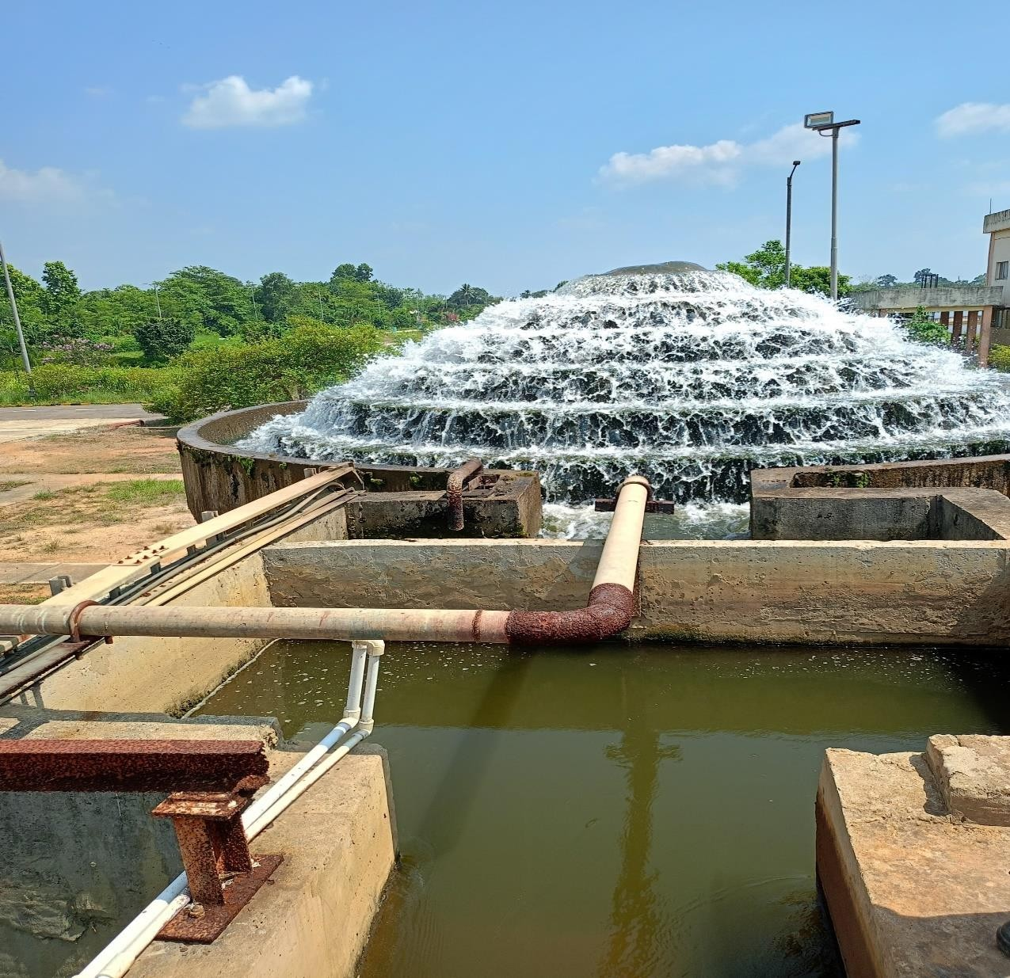**Ensuring Efficiency**: High-quality feedwater is essential for maintaining the thermal efficiency of the power plant and ensuring reliable and uninterrupted operation.

**Fig**: PT plant

##### 4.5.5 FLOWDIAGRAM OF PT PLANT

PRIMARY

TREATMENT

RESERVOIR

GOMATI RIVER

AERATOR

SCREENING

PART

STILLING

CHAMBER

FLASH

MIXER

TELESCOPIC

SLUDGE

COLLECTOR PIT

CLARIFOCCULATOR

DEVICE

MUDDY

THICKENER

WATER

SLUDGE CENTRIFUGAL

SYSTEM

CLEAN WATER

CLARIFIED WATER STORAGE TANK (CSWT)

FILTRATE SUMP

#### 4.6 DEMINERALIZED WATER PLANT (DM PLANT)

A demineralization plant is an advanced water treatment system designed to remove mineral salts from water through ion exchange processes. The plant typically comprises several stages, each employing different mechanisms to ensure comprehensive removal of contaminants. Key components of a demineralization plant include Activated Carbon Filter (ACF), Dual Media Filter (DMF), Strong Acid Cation (SAC) exchange resin, Strong Base Anion (SBA) exchange resin, Mixed Bed exchangers, and mechanisms for treating pH and silica. Each of these components plays a crucial role in producing high-purity water.

###### 4.6.1 Activated Carbon Filter (ACF)

The Activated Carbon Filter (ACF) is the first stage in the demineralization process. ACF uses activated carbon to adsorb organic compounds, chlorine, and other oxidizing agents from the water. This step is crucial for protecting downstream ion exchange resins from

fouling and oxidation. Activated carbon has a high surface area, which makes it effective in trapping organic molecules and reducing taste, odour, and colour issues in the water.

###### 4.6.2 Dual Media Filter (DMF)

Following the ACF, the water passes through a Dual Media Filter (DMF), which typically consists of a layer of anthracite coal above a layer of fine sand. The DMF performs mechanical filtration to remove suspended solids, turbidity, and particulates. The anthracite layer captures larger particles, while the sand layer provides fine filtration, ensuring that the water entering the ion exchange units is free of physical impurities that could clog or damage the resins.

###### 4.6.3 Strong Acid Cation (SAC) Exchange Resin

The Strong Acid Cation (SAC) exchange resin is the next stage where positively charged ions (cations) such as calcium, magnesium, sodium, and potassium are exchanged with hydrogen ions (H+). The SAC resin beads are typically made of a polystyrene matrix with sulfonic acid groups. As water flows through the SAC resin bed, cations in the water are replaced by hydrogen ions, resulting in the removal of hardness and other cationic impurities.

###### 4.6.4 Strong Base Anion (SBA) Exchange Resin

After the cation exchange, the water passes through the Strong Base Anion (SBA) exchange resin. This resin targets negatively charged ions (anions) such as chloride, sulphate, nitrate, and bicarbonate, exchanging them with hydroxide ions (OH-). The SBA resin typically consists of a polystyrene matrix with quaternary ammonium groups. The hydroxide ions released during this exchange combine with hydrogen ions from the SAC process to form pure water (H2O).

###### 4.6.5 Mixed Bed Exchangers

Mixed Bed exchangers contain a mixture of cation and anion exchange resins in a single column. They provide a final polishing step to remove any remaining ionizable impurities and achieve ultra-pure water quality. The mixed bed resin ensures that any traces of cations or anions left after the SAC and SBA processes are exchanged, resulting in water with extremely low conductivity and high resistivity.

###### 4.6.6 pH Adjustment

pH adjustment mechanisms are crucial in the demineralization process to ensure that the treated water maintains a neutral or slightly acidic pH, typically around 7. This is important because water that is too acidic or too alkaline can be corrosive to pipes and equipment. pH adjustment is usually achieved by adding acid or alkali to neutralize any residual acidity or alkalinity in the water, ensuring it is safe for industrial or potable use.

###### 4.6.7 Silica Removal

Silica removal is a critical step, particularly for high-purity water applications such as boiler feedwater or semiconductor manufacturing. Silica can exist in water as reactive silica (SiO2) or as colloidal silica. Ion exchange resins, particularly SBA resins, can remove reactive silica, but additional treatment methods such as reverse osmosis (RO), evaporation, or specific silica adsorbents may be required for complete removal. Silica treatment ensures that scaling and fouling in boilers and other equipment are minimized, enhancing operational efficiency and longevity.

Each of these components works synergistically to produce high-purity demineralized water suitable for various industrial and technological applications. The specific design and sequence of these components can be tailored to meet the unique requirements of different water sources and purity standards.

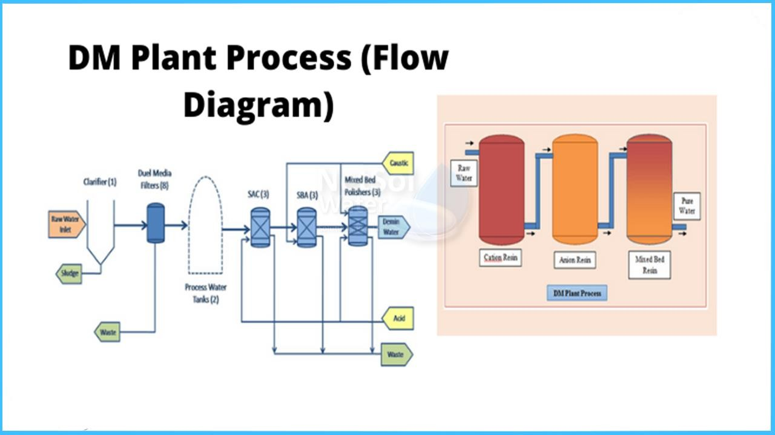

**Fig:** DM plant process flow diagram

#### 4.7 EFFLUENT TREATMENT PLANT (ETP)

The Effluent Treatment Plant (ETP) at ONGC Tripura Power Company (OTPC) in Palatana plays a critical role in managing and treating wastewater generated from various plant operations. As a Combined Cycle Gas Turbine (CCGT) power plant, OTPC utilizes large volumes of water for cooling, boiler feed, and auxiliary processes, which in turn generates multiple types of effluents, including oily water, chemical-laden wastewater from the DM plant, cooling tower blowdown, and domestic sewage.

The ETP is designed to treat this effluent using a combination of physical, chemical, and biological treatment processes to ensure compliance with environmental norms set by the Central and State Pollution Control Boards. Key components of the ETP include oil and grease separators, equalization and neutralization tanks, coagulation and flocculation units, clarifiers, biological treatment reactors (such as MBBR), and multi-media filters like sand and activated carbon beds.

The treated water is either safely discharged into natural water bodies after meeting permissible standards or reused within the plant for non-critical applications such as ash handling and gardening. The ETP is integrated with a SCADA-based monitoring system for real-time tracking of water quality parameters such as pH, BOD, COD, and TDS, ensuring efficient operation and environmental compliance. This system not only ensures sustainable water management but also supports OTPC's commitment to environmental protection and operational safety.

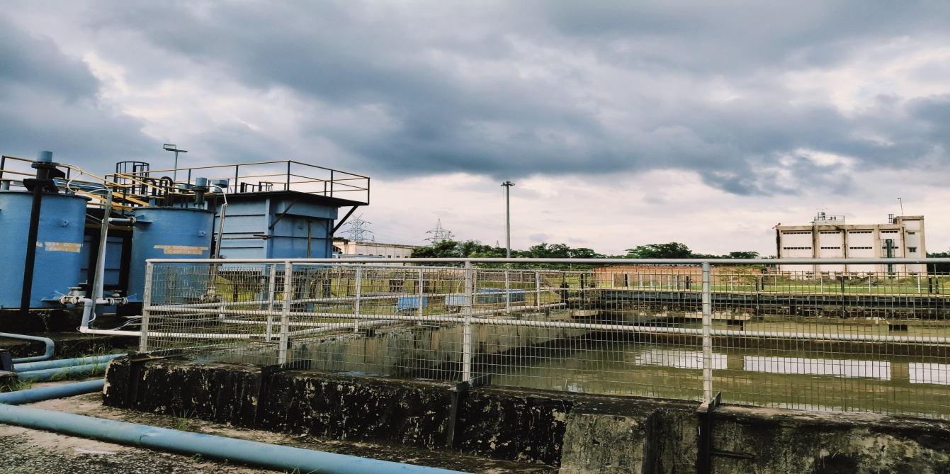

**Fig:** Effluent Treatment Plant (ETP)

#### 4.8 COMPLETE WATER CYCLE

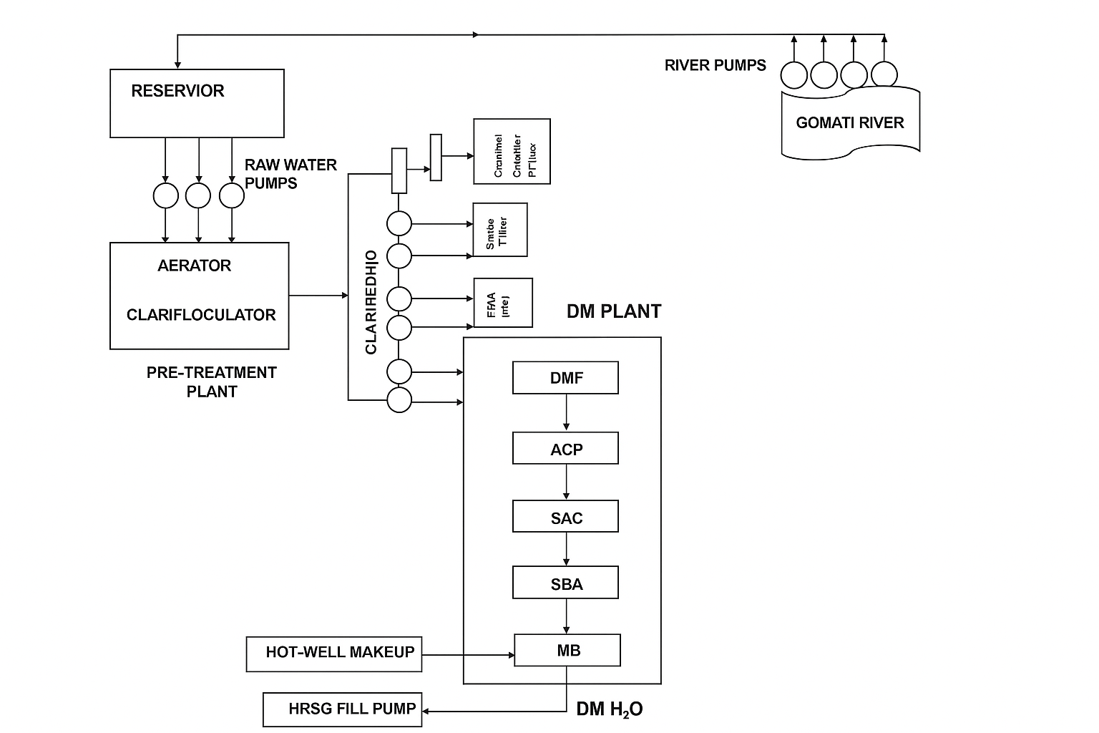

**DRAINAGE**

**WATER**

**FROM DIFFERENT**

**SEGMENT**

**EFFLUENT**

**TREATMENT**

**PLANT**

#### 4.9 COMPLETE STEAM TURBINE

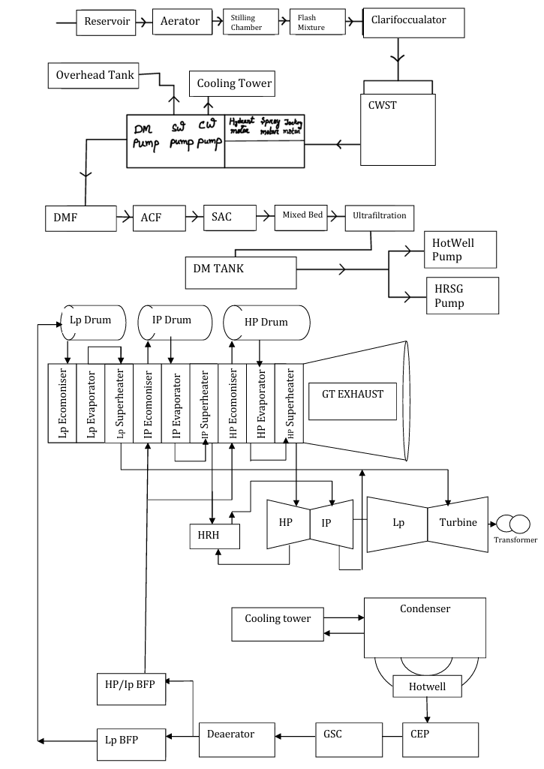

Generator

**GOMATI**

Transformer

## 5. NITROGEN PRODUCTION PLANT

It is an accessory plant used for on-site production of nitrogen gas which is used to serve a number of purposes like purging of vessels and as secondary seals in GBC.

Principle: The N₂ and O₂ are the major constituents of air. So removal O₂ will leave only with N₂. So the N₂ production is basically an oxygen removal process which is done by using oxygen absorbents such as alumina (Al₂O₃).

## 6. HYDROGEN PRODUCTION PLANT

At the ONGC Tripura Power Company (OTPC) in Palatana, a dedicated hydrogen generation plant is used primarily for cooling the generators in its combined-cycle gas turbine (CCGT) setup. Hydrogen is selected as a cooling medium because of its superior thermal conductivity and low density, which significantly reduces windage losses and enhances generator efficiency.

The hydrogen plant at OTPC typically operates using an **alkaline electrolyzer system**, where **demineralized water** is split into hydrogen and oxygen through the process of electrolysis. The electrolyte used in this process is a **potassium hydroxide (KOH) solution**, which facilitates ionic conductivity and ensures efficient electrochemical separation. The resulting hydrogen is of high purity—generally exceeding 99.9%—and is stored in high-pressure buffer tanks for continuous and safe supply to the generator casing. The system includes essential components such as hydrogen dryers, purity analyzers, flame arrestors, and automatic shut-off valves, all monitored through a SCADA-based control system. Safety is paramount in hydrogen handling; thus, the plant is equipped with hydrogen leak detectors, pressure relief valves, proper earthing, and CO₂-based purging systems to prevent any explosive mixtures. This in-house hydrogen generation not only ensures uninterrupted cooling of the generators but also eliminates dependency on cylinder-based supplies, making the plant more efficient, safe, and self-reliant in a remote location like Palatana.

## 7. SWITCHYARD

The switchyard at ONGC Tripura Power Company (OTPC) in Palatana plays a crucial role in transmitting the generated electricity from the plant to the regional and national power grids. As OTPC operates a 726.6 MW Combined Cycle Gas Turbine (CCGT) plant, the switchyard is equipped to handle high-voltage transmission at both 400 kV and 132 kV levels. Power generated at around 11.5 kV is stepped up using generator transformers and routed through the switchyard to Power Grid Corporation of India’s 400 kV double-circuit transmission lines, which connect to Assam and the broader North Eastern Region (NER) grid. The switchyard comprises essential components such as SF₆ circuit breakers, current and potential transformers, busbars, isolators, lightning arresters, earth switches, and wave traps, all arranged in a double busbar or main and transfer bus configuration for operational flexibility and reliability. It is integrated with a SCADA system, allowing real-time monitoring, remote operation, and fault analysis. The switchyard also includes comprehensive protection systems such as distance relays, differential protection, and breaker failure schemes to ensure safety and continuity of power supply. Proper grounding, isolation, and adherence to Central Electricity Authority (CEA) and CBIP standards ensure the highest levels of operational safety. The switchyard is thus a vital interface between the power plant and the transmission network, enabling efficient and reliable delivery of electricity generated at OTPC to both Tripura and the surrounding northeastern states.

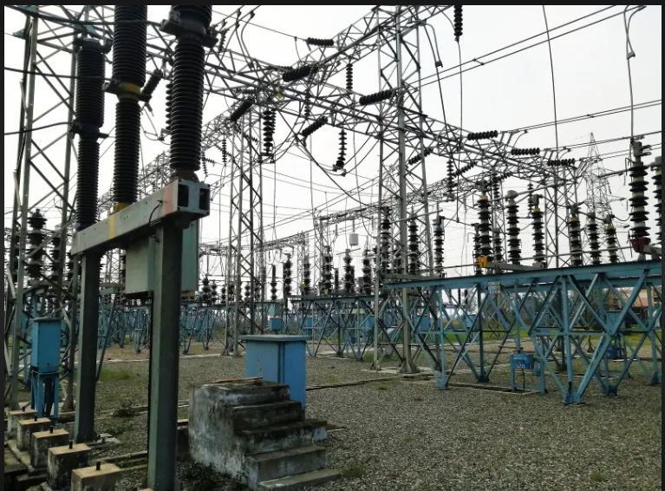

**Fig:** Switchyard

#### COMPLETE CCGT CYCLE

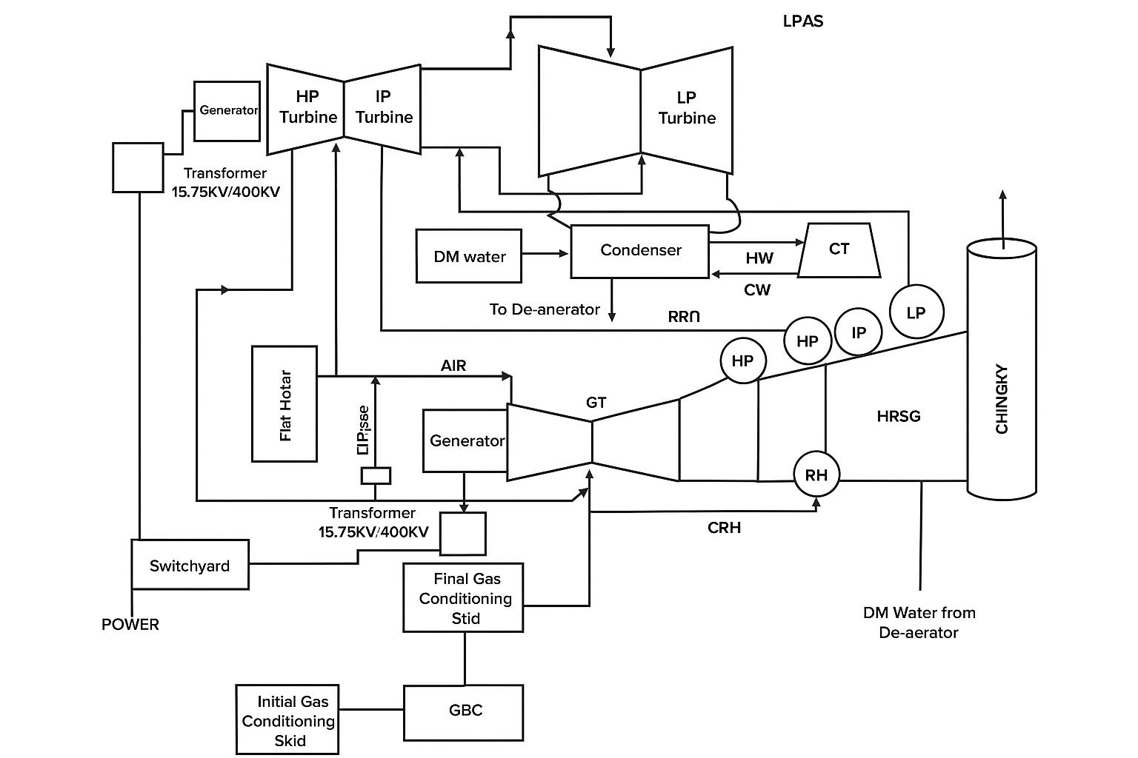

Chimney

Filter

LPMS

HPMS

IPMS

HRH

IP

ONGC

GAS SUPPLY

## 8. CONTROL SYSTEM

The control system at ONGC Tripura Power Company (OTPC), Palatana, is a highly integrated and automated Distributed Control System (DCS) designed to operate and monitor the combined cycle gas-based power generation process. The plant comprises Gas Turbines (GT), Heat Recovery Steam Generators (HRSG), and a Steam Turbine (ST), all coordinated to maximize efficiency and reliability. Each Gas Turbine unit is equipped with dedicated digital controllers for speed and load control, inlet guide vane regulation, and combustion management. The GT system typically uses PID controllers and safety Programmable Logic Controllers (PLCs) to ensure safe start-up, temperature control, and emergency shutdowns.

The HRSG system uses three-element PID controllers for boiler drum level control, along with additional controllers for steam pressure, flue gas temperature, and deaerator level, ensuring efficient heat recovery. The Steam Turbine is governed by a load and speed control system integrated with a PID-based temperature regulation system, and includes gland sealing control to maintain turbine integrity. Feedwater and condensate systems rely on PID controllers for level and flow regulation, while safety PLCs provide pump protection. The cooling water system is managed by temperature-controlled PID loops and logic controllers for fan and pump operation. Generator control includes Automatic Voltage Regulators (AVR), synchronizers, and excitation controllers to maintain voltage and frequency stability during grid operation. Additionally, the fuel gas system features precise PID and PLC-based controllers for flow and pressure regulation, complemented by fire and gas detection systems using redundant safety PLCs for automatic shutdown and alarm activation during hazardous events. All these subsystems are interconnected through a central DCS, which serves as the operational core of the plant. It provides real-time monitoring, historical data logging, alarm management, and Human-Machine Interface (HMI) for operators. The use of redundant controllers, high-speed communication networks, and intelligent field devices ensures that the plant operates safely, efficiently, and with minimal manual intervention—critical for a remote and strategic plant like OTPC Palatana.

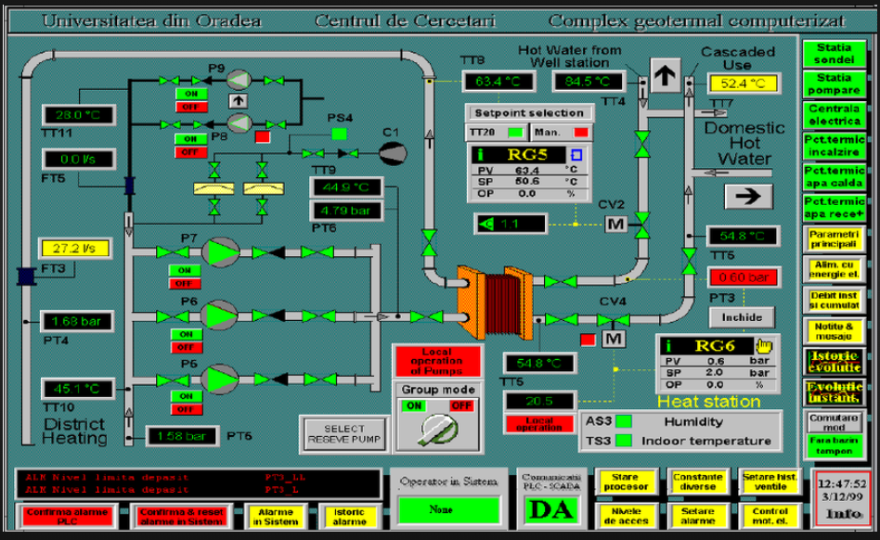

**Fig: DCS**

At ONGC Tripura Power Company (OTPC) Palatana, the SCADA (Supervisory Control and Data Acquisition) system plays a vital role in ensuring centralized monitoring, control, and data analysis across various critical operations of the combined cycle gas-based power plant. The SCADA system interfaces with key equipment such as gas turbines, heat recovery steam generators (HRSG), steam turbines, auxiliary pumps, fuel gas skids, and electrical switchgear to provide real-time operational data to plant operators. It is integrated with Remote Terminal Units (RTUs), Programmable Logic Controllers (PLCs), and the Distributed Control System (DCS) to collect data from field instruments measuring parameters like temperature, pressure, flow rate, vibration, and voltage. This data is then processed and visualized through a Human-Machine Interface (HMI), enabling operators in the central control room to supervise the entire plant, issue remote control commands, analyze historical trends, and respond quickly to alarms or abnormal conditions. SCADA is especially critical in OTPC’s operation due to the strategic and remote location of the plant, where high reliability and minimal manual intervention are essential. It facilitates efficient load balancing, equipment diagnostics, fault isolation, and performance optimization. The integration of SCADA with OTPC’s automation architecture ensures a seamless flow of information, supporting both plant-wide control and decision-making, ultimately contributing to the safety, stability, and reliability of power generation for the northeastern grid.

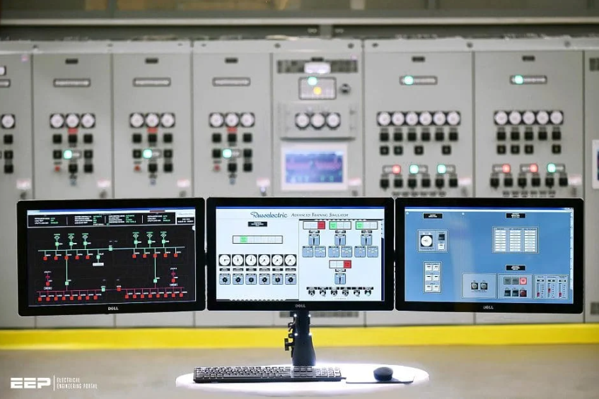

**Fig:** Supervisory Control and Data Acquisition (SCADA)

A Distributed Control System (DCS) is integral to modern power plants, providing a sophisticated platform for centralized monitoring and control. It features a decentralized architecture with control stations near process units, human-machine interfaces (HMIs) for operators, engineering workstations for system configuration, a high-speed communication network, and various field devices. DCS functions encompass process control, real-time data acquisition, alarm management, safety interlocks, and load management. These capabilities enhance efficiency, safety, and reliability, with the system designed for redundancy to prevent failures. By optimizing processes and enabling predictive maintenance, DCS reduces downtime and improves overall plant performance, offering scalability and centralized control for streamlined operations.

For Gas Turbine- Mark VIe Control System; For Steam Turbine- MaxDNA System

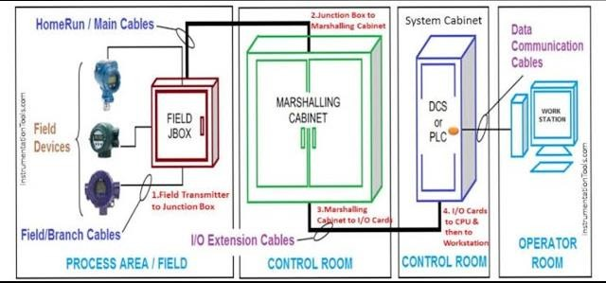

**Fig**: Instrumentation control system architecture

#### 

#### 8.1 MAXDNA

MaxDNA is a fully integrated control system designed for control of Steam turbine. MaxDNA DCS system consists of a modem Windows XP-based human machine interface max VUE, maxTools. These systems are connected to the DPU (Digital Processing Unit) and maxPAC I/O system. The transmitters used in the field are transducers Which Sense the Change in physical environment and converts it into corresponding electrical signals which is generally current signal ranging from 4 mA to 20 mA. These signals are sent to the Junction Box (JB) and through signal cables. These cables are used for bidirectional communication. From JB the cables are taken to Control Equipment Room (CER). In CER. there is a Terminal Board (TB) where input lines from JB enter the 16-channel module. These are connected via input lines to different I/O modules according to the signal they Carry like analog input module, Digital Input module, RTD module, Thermocouple module etc. The front side of the terminal board is in the form of racks which is generally 4 in number. The first rack is the primary rack while below is the hot backup rack.

Whenever a critical card in the primary rack fails the backup takes over the entire primary rack. The CAT -5 cables connect the DPUs. The first module in the rack is DPU' (Digital Processing Unit) and the second module is kept empty. The rest modules contain I/O cards. Signal goes from DPU to different cards. The I/O cards are connected to the DPU by back plane.

#### 8.2 SPEEDTRONIC MARK VIe

SPEEDTRONIC Mark VI turbine control is the control system used for GE turbine. It is designed as an integrated protection and monitoring System for turbine, heart of the control system is Control Module which is available as 13 or 21 slot standard VME card rack. Inputs are received by the control module through termination blocks. Each I/O card contains a DSP processor to digitally filter the data before conversion to 32-bit floating-point format. In addition to the I/O cards. the Control Module contains an internal communication card. a main processor card and sometimes a flash disk card. Each card takes one slot except for the main processor which takes two slots. I/O data transmitted on the VME backplane between the I/O cards and the VCMI is used for internal communications. Mark VI control systems are available in Simplex and Triple Redundant forms. The name Triple Module Redundant (TMR) is derived from the basic architecture with three completely separate and independent control modules, power supplies.

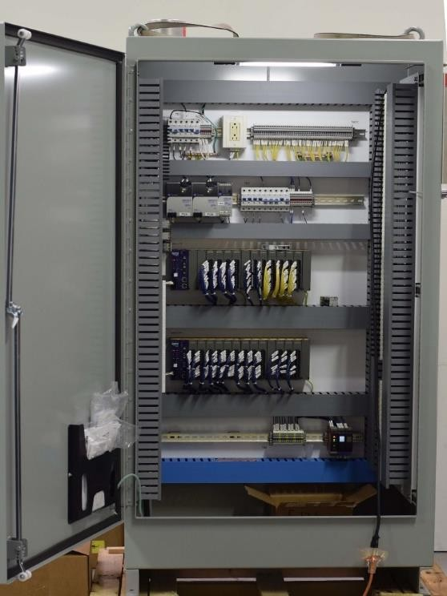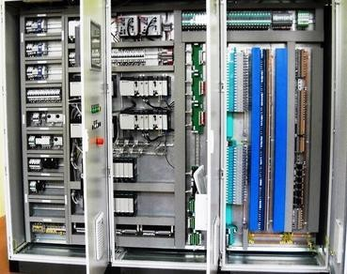

**Fig**: DCS Panels

#### 9. FIELD INSTRUMENTS

**9.1 Resistance Temperature Detector (RTD):** Resistance Temperature Detectors (RTDs) provide precise temperature measurements necessary for optimizing and controlling various processes. These sensors, typically made of platinum, are highly accurate and stable over a wide temperature range, making them ideal for the demanding conditions in power plants. RTDs are used to monitor the temperature of gas turbine exhaust gases, steam, and feedwater in the Heat Recovery Steam Generator (HRSG), as well as steam entering and exiting the steam turbine. They are also essential in cooling systems to ensure components remain within safe operating temperatures and in boiler drums to maintain proper water levels. By offering accurate temperature data, RTDs enhance the efficiency, safety, and reliability of combined cycle power plants, enabling better process control and preventing equipment damage.

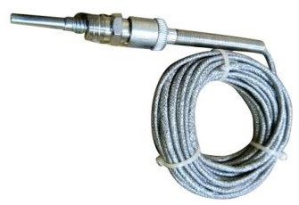

**Fig**: RTD pt-100

**9.2 Thermocouple:** Thermocouples are essential temperature sensors used in power plants for their wide temperature range, robustness, and rapid response time. Comprised of two dissimilar metals joined at one end, thermocouples generate a voltage proportional to the temperature difference between the junction and the reference point. In power plants, they monitor critical temperatures in gas turbines, such as exhaust gases, to optimize combustion and prevent overheating. They are also used in the Heat Recovery Steam Generator (HRSG) to measure temperatures of exhaust gases, steam, and feedwater, and in steam turbines to monitor inlet and outlet steam temperatures. Their durability and reliability make thermocouples vital for maintaining efficient, safe, and controlled plant operations.

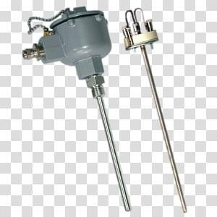

**Fig**: Thermocouple

**9.3 Actuator:** A pneumatic controlled actuator is a device that uses compressed air to convert energy into mechanical motion, playing a crucial role in power plants by automating the control of valves and dampers. These actuators consist of a piston or diaphragm that moves when air pressure is applied, translating the pneumatic force into linear or rotary motion to open or close valves and regulate fluid flow. In power plants, pneumatic actuators are essential for controlling steam, water, and fuel flow, ensuring precise regulation of pressure, temperature, and flow rates within boilers, turbines, and heat exchangers. Their advantages include fast response times, high reliability, and the ability to operate in hazardous environments without risk of ignition, making them ideal for the demanding and safety-critical conditions of power generation. Additionally, pneumatic actuators are relatively simple to maintain and can be easily integrated with control systems for automated operation, contributing to improved efficiency, safety, and operational flexibility in power plant processes.

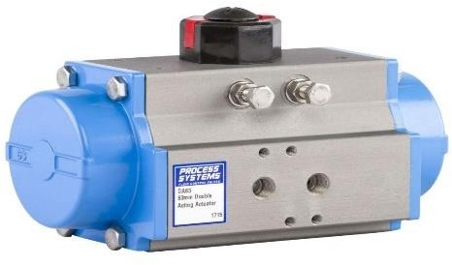

**Fig**: Actuator

**9.4 Control Valve**: Control valves are essential components in power plants, used to regulate the flow of fluids such as steam, water, and gases throughout the plant’s systems. These valves adjust the flow rate by varying the size of the flow passage based on signals from controllers, ensuring precise control over pressure, temperature, and fluid levels. In power plants, control valves are critical for optimizing the operation of boilers, turbines, condensers, and cooling systems. They manage the steam flow to turbines, which directly impacts electricity generation efficiency and safety. In boiler systems, control valves regulate the feedwater supply, maintaining proper water levels and pressure to ensure efficient steam production and avoid overheating. They are also used in fuel systems to control the supply of fuel to burners, impacting combustion efficiency and emission levels. By providing accurate and responsive flow control, control valves enhance the plant’s operational stability, safety, and efficiency, and they are integral to automated control systems, enabling real-time adjustments and consistent performance in dynamic operating conditions.

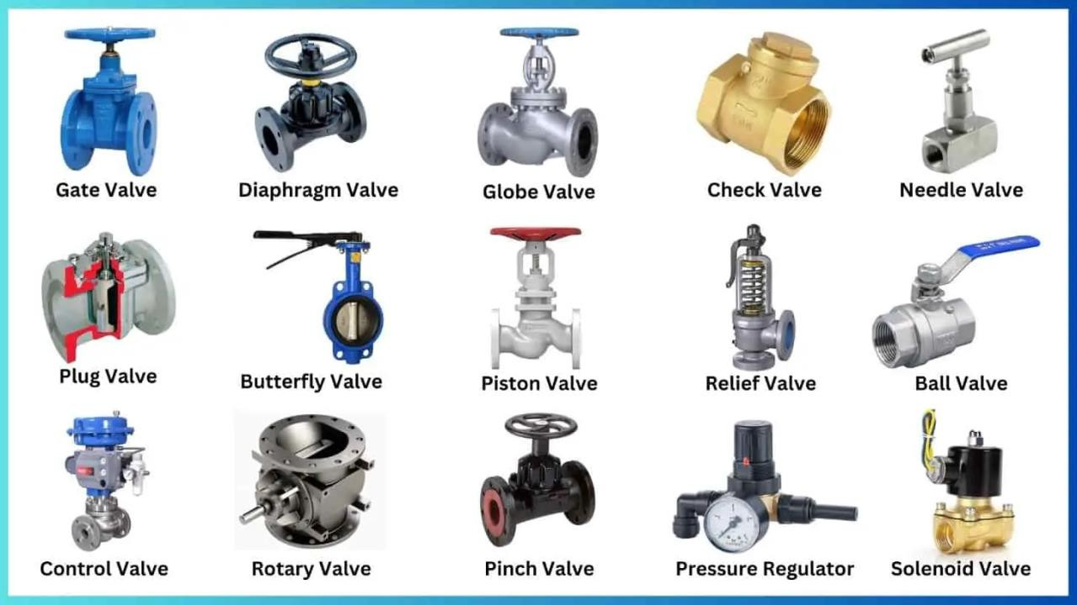

**9.5 Solenoid Valve (SOV):** A solenoid valve is an electromechanically operated valve that uses an electric current to control the flow of fluids or gases. It consists of a solenoid coil, which, when energized, generates a magnetic field that moves a plunger, opening or closing the valve. Solenoid valves are widely used in various applications due to their reliability, fast response times, and ease of integration with automated systems. In power plants, solenoid valves are critical for controlling the flow of steam, water, and fuel, playing a key role in safety systems by quickly shutting off or diverting flow in emergency situations. They are also used in boiler control systems to manage feedwater and fuel supply, ensuring precise operation and enhancing overall plant efficiency. The ability to operate solenoid valves remotely and their suitability for rapid cycling make them invaluable for achieving precise control in complex power plant operations.

**9.6 Pneumatic valve:** A pneumatic valve is a valve that uses compressed air to control the flow of fluids or gases, utilizing an actuator powered by air pressure to open, close, or modulate the valve position. These valves are known for their durability, reliability, and fast response times, making them ideal for applications requiring rapid and precise control. In power plants, pneumatic valves are essential for regulating steam, water, and fuel flows within boilers, turbines, and cooling systems, ensuring optimal operation and safety. They are particularly useful in harsh environments where electrical actuators may pose ignition risks, as they do not produce sparks and can operate in explosive atmospheres. Additionally, pneumatic valves are relatively simple to maintain and can be easily integrated into automated control systems, enhancing the plant’s operational efficiency, flexibility, and safety.

**9.7 Motor operated valve (MOV):** A motor-operated valve (MOV) is a valve controlled by an electric motor, providing precise regulation of fluid or gas flow in various industrial applications, including power plants. The electric motor drives the valve stem to open, close, or modulate the valve position, enabling automated and remote operation. In power plants, MOVs are crucial for controlling the flow of steam, water, and other fluids in systems such as boilers, turbines, and cooling circuits. They ensure accurate and reliable flow control, contributing to the efficiency and safety of the plant operations. MOVs are often used in critical applications where precise flow adjustments are necessary to maintain optimal operating conditions, such as regulating steam pressure to turbines or controlling feedwater supply to boilers. Their ability to integrate with control systems allows for real-time monitoring and adjustments, enhancing the overall performance and reliability of power generation processes.

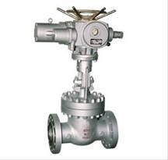

**Fig:** Motor Operated Valve

**9.8 Rotameter:** A rotameter is a simple and cost-effective flow meter used to measure the flow rate of liquids or gases in industrial applications. It consists of a tapered tube with a float inside that rises and falls according to the flow rate, providing a visual indication of the flow. Rotameters are commonly used in power plants for monitoring and controlling the flow of water, steam, air, and other fluids in various systems such as boilers, cooling circuits, and gas lines. Their straightforward design, low maintenance requirements, and ease of installation make them suitable for a wide range of flow measurement applications, providing operators with valuable insights into process performance.

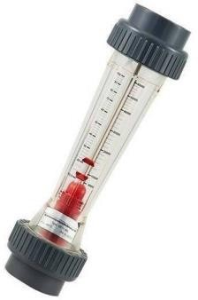

**Fig**: Rotameter

**9.9 Pressure Switch:** Pressure switches are vital components in power plants, serving to monitor and control fluid or gas pressure levels within critical systems. These switches are designed to detect changes in pressure and actuate electrical contacts to initiate specific actions when predetermined pressure thresholds are reached. In power plants, pressure switches are deployed across various applications such as boiler systems, steam turbines, hydraulic systems, and pneumatic circuits, ensuring safe and efficient operation by triggering alarms, shutting down equipment, or activating safety protocols in response to abnormal pressure conditions. Their reliability, responsiveness, and versatility make pressure switches indispensable for maintaining optimal performance and safeguarding assets in power generation facilities.

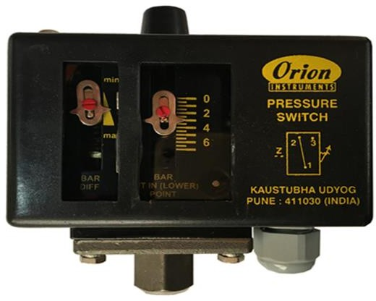

**Fig**: Pressure switch

**9.10 Temperature switch**: Temperature switches are indispensable components in power plants, dedicated to monitoring and regulating temperature levels within critical systems. These switches are engineered to detect changes in temperature and trigger electrical contacts to initiate predetermined actions when specific temperature thresholds are reached. Deployed across various applications such as boilers, turbines, heat exchangers, and cooling systems, temperature switches play a pivotal role in ensuring operational safety, efficiency, and reliability. By promptly detecting and responding to temperature fluctuations, they help prevent overheating, equipment damage, and operational disruptions, thereby contributing to the smooth and uninterrupted functioning of power generation processes.

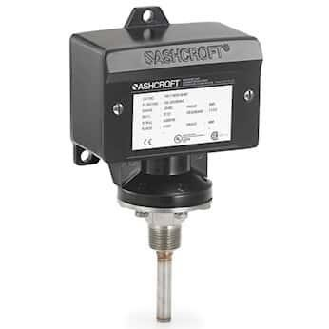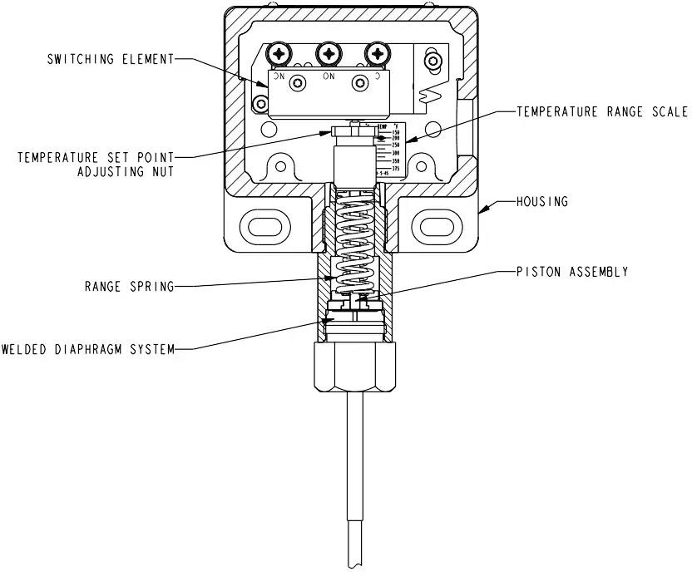

**Fig:** Temperature Switch

**9.11 Flow Transmitter:** A flow transmitter is an instrument used to measure and transmit flow rate data in industrial processes. It typically consists of a sensor that detects the flow of liquids or gases, along with a transmitter that converts the sensor's output into a standardized signal, such as 4-20 mA or digital signals, for remote monitoring and control. Flow transmitters are essential in power plants for accurately measuring the flow of water, steam, fuel, and other fluids in various systems such as boilers, turbines, condensers, and cooling circuits. Their ability to provide real-time flow data enables operators to optimize process efficiency, troubleshoot issues, and ensure smooth operation of power generation facilities.

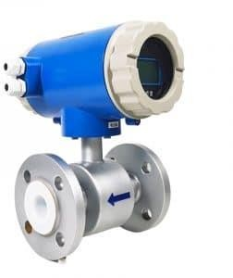

**Fig:** Flow transmitter

**9.12 Level Transmitter:** A level transmitter is an instrument used to measure and transmit liquid or solid levels in tanks, vessels, or other containers in industrial processes. It typically employs various technologies such as pressure, ultrasonic, capacitance, or radar to determine the level of the substance being measured. The transmitter then converts this level information into a standardized signal, such as 4-20 mA or digital signals, for remote monitoring and control. In power plants, level transmitters are crucial for accurately monitoring the levels of water, steam, fuel, and other fluids in boilers, condensers, storage tanks, and other critical components, ensuring safe and efficient operation of the plant.

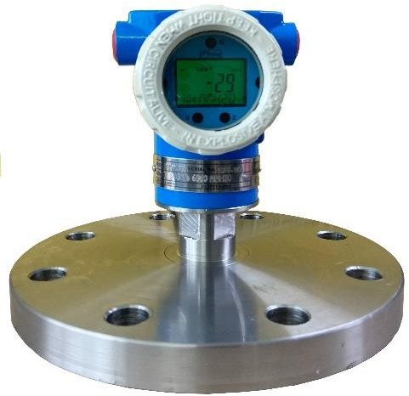

**Fig:** Level Transmitter

**9.13 pH Transmitter:** A pH transmitter is an instrument used to measure and transmit the pH level of a liquid in industrial processes. It typically consists of a pH sensor or electrode that detects the acidity or alkalinity of the liquid, and a transmitter that converts this pH measurement into a standardized signal, such as 4-20 mA or digital signals, for remote monitoring and control. pH transmitters are essential in power plants for monitoring the pH levels of water used in boilers, cooling systems, and other processes. Maintaining the proper pH level is crucial for preventing corrosion, scaling, and other issues that can affect the efficiency and lifespan of plant equipment.

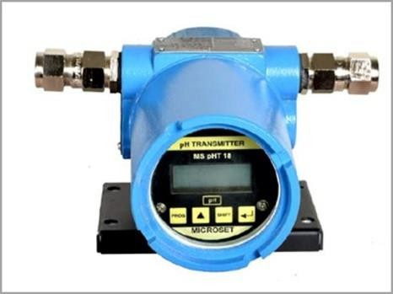

**Fig:** pH Transmitter

**9.15 Temperature Transmitter:** A temperature transmitter is an instrument used to measure and transmit temperature data in industrial processes. It typically consists of a temperature sensor, such as a thermocouple or RTD, and a transmitter that converts the temperature measurement into a standardized signal, such as 4-20 mA or digital signals, for remote monitoring and control. Temperature transmitters are essential in power plants for accurately monitoring the temperature of fluids, gases, and equipment in various systems such as boilers, turbines, heat exchangers, and cooling circuits. By providing real-time temperature data, these transmitters enable operators to optimize process efficiency, ensure equipment safety, and prevent overheating or damage in critical components, contributing to the reliable and efficient operation of the plant.

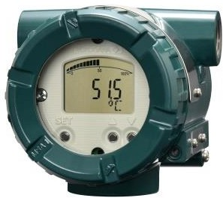

**Fig:** Temperature Transmitter

**9.16 Air Lock Relay:** An air lock relay is an electromechanical device used to control the operation of air locks in industrial settings, including power plants. It typically consists of a relay coil and contacts that are actuated by changes in air pressure. Air lock relays are employed to ensure the safe and efficient operation of air locks, which are used to control the flow of air or gases between different pressure zones. In power plants, air lock relays play a crucial role in maintaining the integrity of containment areas, preventing the release of hazardous gases or contaminants, and facilitating the movement of personnel and equipment between different areas with varying pressure levels.

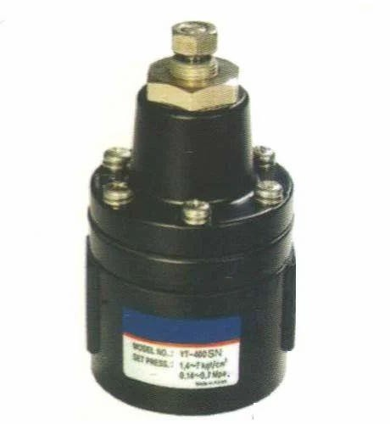

**Fig:** Air Lock Relay

#### 10. CALIBRATION INSTRUMENTS:

**10.1 Dead Weight Tester:** A dead weight tester is a calibration instrument used to accurately measure pressure by balancing a known force with the pressure being tested. It typically consists of a piston-cylinder assembly, weights, and a pressure gauge. The pressure to be tested is applied to the piston, causing it to move and balance against the known weights. The resulting pressure is indicated on the gauge, providing a precise calibration reference for other pressure instruments. Dead weight testers are widely used in industrial settings, including power plants, for calibrating pressure gauges, transmitters, and other pressure-measuring devices with high accuracy and reliability.

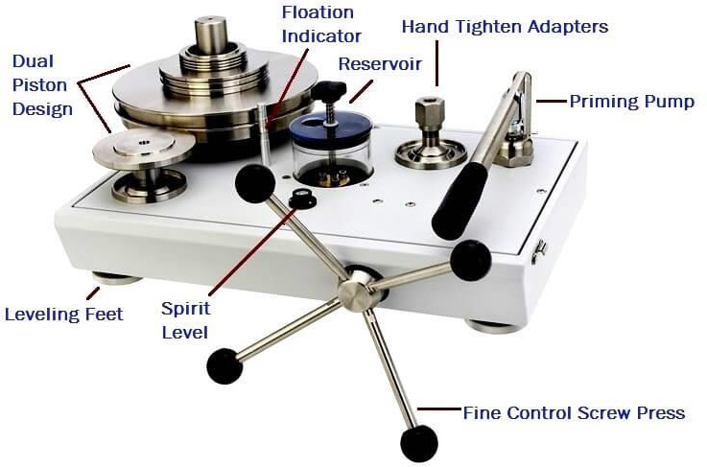

**Fig:** Dead weight Tester

**10.2 Dry Block Calibrator:** A dry block calibrator is a portable instrument used to calibrate temperature sensors and thermometers by providing a stable and uniform temperature environment. It consists of a metal block with machined holes where temperature probes are inserted for calibration. The block is heated or cooled using electric heaters or thermoelectric elements to reach and maintain precise temperature setpoints. Dry block calibrators offer quick and accurate calibration of temperature sensors in the field or laboratory, ensuring reliable measurement accuracy and traceability. They are widely used in various industries, including power plants, for calibrating temperature instruments with high efficiency and convenience.

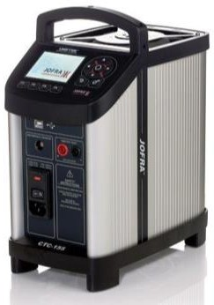

**Fig:** Dry Block Calibrator

## 11.CONCLUSION

In conclusion, the summer training at ONGC Tripura Power Company Limited (OTPC), located in Palatana, Tripura, has been an enriching and insightful experience. The combined cycle power plant at Palatana stands as a testament to modern engineering excellence, utilizing natural gas as its primary fuel source to generate electricity efficiently and sustainably.

The plant operates on a combined cycle configuration, comprising gas turbines, steam turbines, and heat recovery steam generators, to maximize energy conversion and minimize environmental impact. Through its advanced technology and operational practices, OTPC contributes significantly to the society and environment by providing a reliable source of clean energy to the region.

OTPC is promoted by GOT (Govt. Of Tripura), Infrastructure Leasing & Financial Services Ltd. (IL&FS) and Oil and Natural Gas Corporation (ONGC).

The project consists of two units of capacity 363.3 MW Combined Cycle Gas Based Turbine (CCGT). OTPC sales its generated power to the North Eastern States viz. Assam, Tripura, Meghalaya, Manipur, Arunachal Pradesh, Nagaland, Mizoram that are connected through NEWNE grid and 13.5% to any entity in the country via regional grid.

The project would supply clean power to the national transmission grid wherein the present grid mix is relatively skewed towards power generation from coal- based plants. Consequently, implementation of the project Would lead to a reduction in Carbon-dioxide emissions by feeding clean power into the grid.

By harnessing natural gas, a cleaner-burning fossil fuel, OTPC helps reduce greenhouse gas emissions and air pollutants compared to traditional coal-fired power plants, thus contributing to improved air quality and mitigating climate change impacts. Furthermore, the plant's efficient use of resources and adherence to stringent environmental regulations underscore its commitment to sustainability and environmental stewardship.

In essence, the Palatana combined cycle power plant represents a sustainable energy solution that not only meets the region's growing electricity demands but also promotes a greener and more environmentally friendly future for generations to come.

## 12. BIBLIOGRAPHY

• **Wikipedia contributors.** (n.d.). ONGC Tripura Power Company. Wikipedia. Retrieved June 2025, from <https://en.wikipedia.org/wiki/ONGC_Tripura_Power_Company>

• **Wikipedia contributors.** (n.d.). Effluent treatment plant. Wikipedia. Retrieved June 2025, from <https://en.wikipedia.org/wiki/Effluent_treatment_plant>

• **Wikipedia contributors.** (n.d.). Switchyard. Wikipedia. Retrieved June 2025, from <https://en.wikipedia.org/wiki/Switchyard>

• **Google Images.** (n.d.). Photographs and diagrams used for reference. Retrieved June 2025, from <https://images.google.com>

• **Wikipedia contributors.** (n.d.). SCADA. Wikipedia. Retrieved June 2025, from <https://en.wikipedia.org/wiki/SCADA>